HARDWOOD SILVICULTURE COOPERATIVE
RED ALDER STAND MANAGEMENT STUDY
FIELD MANUAL

Revised September 2003

Andrew A. Bluhm
Alison Luckett Bower
Karl Buermeyer
Glenn R. Ahrens
David Hibbs

Hardwood Silviculture Cooperative
Forest Science Department
Oregon State University
Corvallis, OR 97331
TABLE OF CONTENTS
Page
SUMMARIES OF TREATMENTS
Type 1/Thinned Natural Alder Stands..........................…...... vi
Type 2/Alder Variable Density Plantations.....................….... vi
Type 3/Mixed Alder/Douglas-Fir Plantations...................…… vi

SUMMARIES OF PROCEDURES
Type 1/Thinned Natural Alder Stands..........................…...... vii
Type 2/Alder Variable Density Plantations........................... viii
Type 3/Mixed Alder/Douglas-Fir Plantations......................... xi

1. INTRODUCTION...........................................................………... 1

2. TYPE 1/THINNED NATURAL ALDER STANDS...................... 2
2.1 Site selection.........................................................……… 2
2.1.1 Stand size and boundaries..............................… 2
2.1.2 Stocking and composition ............................…. 5
2.1.3 Site index class..........................................…… 6
2.1.4 Stand uniformity.........................................…… 9
2.2 Plot layout and documentation procedure....................…. 9
2.2.1 Plot location..............................................……. 9
2.2.2 Surveying and marking ................................…. 13
2.2.3 Plot referencing and mapping.........................… 15
2.2.4 Signs, protection, and long-term planning....….. 15

2.2.5 Stand establishment documentation .................. 15
2.3 Spacing treatments..................................................…….. 16
2.3.1 Treatment allocation....................................….. 16
2.3.2 Marking spacing treatments...........................… 16
2.3.3 Tagging and pre-treatment measurements.....…. 17
2.3.4 Cutting.....................................................…….. 21
2.4 Data collection and installation maintenance................... 21
2.4.1 Establishment data collection............................ 21
2.4.2 Measurements ..........................................……. 21
2.4.3 Remeasurement and plot maintenance.............. 24
2.4.4 Destructive sampling in wide buffer strip......... 24
2.4.5 Product recovery monitoring ........................... 25

3. TYPE 2/ALDER VARIABLE DENSITY PLANTATIONS ....... 26
3.1 Site selection.........................................................……… 26
3.1.1 General considerations..................................…. 26
3.1.2 Unit size ..................................................…….. 26
3.1.3 Site index class...........................................…… 27
3.1.4 Site uniformity and mortality hazards.............… 28
3.2 Planting block establishment procedures.......................… 28
3.2.1 Planting block layout and delineation.............… 28
3.2.2 Initial spacing and re-spacing
treatment allocation....................................…. 31
3.2.3 Planting block referencing and mapping........… 31
3.2.4 Seed collection and seedling culture .............… 32

3.2.5 Plantation establishment ..............................…. 33
3.2.6 Post-planting monitoring plots ...................…... 35
3.2.7 Signs, protection, and long-term planning.....…. 35
3.2.8 Stand establishment documentation .............….. 36
3.3 Data collection and installation maintenance.............…... 36
3.3.1 Plantation evaluation, initial measurements,
and measurement plot installation..........…... 36
Year 1 evaluation....................................…... 36
Year 2 evaluation...................................….... 37
Determination of establishment ...............….. 37
Measurement plot location, delineation, and
treatment allocation.................................…... 37
3.3.2 Post-establishment measurements, re-spacing,
and remeasurement..................................….. 38
Year 3 remeasurement.............................…... 38
3-5 year re-spacing .................................….... 41
Pruning treatment ...................................….... 42
Year 6 remeasurement.............................…... 44
Later re-spacing treatments .....................….... 44
3.3.3 Destructive sampling in wide buffer strips....…. 44
3.3.4 Product recovery monitoring ......................…... 45

4. TYPE 3/MIXED ALDER/DOUGLAS-FIR PLANTATIONS.…... 46
4.1 Site selection.......................................................……….. 46
4.1.1 Stand size and boundaries...........................…... 46

4.1.2 Stocking and composition ..........................…... 47
4.1.3 Site index................................................……... 48
4.1.4 Stand uniformity and damage hazards..........….. 49
4.2 Plot layout, establishment, and measurement .............…. 49
4.2.1 Plantation establishment ............................…... 49
4.2.2 Establishment in existing stands..................….. 50
4.2.3 Remeasurement........................................…….. 50

APPENDICES
A. Installation access and plot maps
A-1 Sample of Installation Access Sketch Map.........…….... 52
A-2 Sample Planting Block Map, Type 2...................……… 53
A-3 Sample Measurement Plot Installation Map, Type 1..…. 54
B. Stand establishment information sheet....................................…... 56
C. Locating DBH, Measuring, and Marking
Determination and marking of DBH................................…... 60
C-1. Location of DBH on Various Trunk Types...............….. 61
D. Tagging Methods
D-1 Barlock/tag method for tagging alder.........................…. 63

E. Coding instructions and data formats
Format 3. Type 1 Pre-treatment Stem Densities...........…….. 65
Format 5. Type 2 Plantation Monitoring Data........................ 68
Format 6. Type 2 Pre-treatment Stem Densities..................... 71
Format 7. Type 2 Plantation Remeasurement Data.................. 74
Format 8. Type 2 Seedling Sample: Size at Time of Planting.. 79
Comment Codes……………………………………………….. 80
F. Red alder site quality evaluation guide (Harrington, 1986)............. 83

LIST OF TABLES
Table 1. Type 1/Thinned natural alder stand treatments.............…… 5
Table 2. Nominal tree spacing and spacing tolerances for
Type 1 installations.................................................………..... 17
Table 3. Order of Type 1 thinning treatment tasks performed
in the growing vs. dormant season.................................…….. 18
Table 4. Sampling matrix for Type 2 plantation establishment............ 27
Table 5. Type 2/alder variable density plantation treatments............... 30
Table 6. Planting densities, tree spacing, and tolerances for
Type 2 (plantation) installations...................................…..... 34
Table 7. Prune height and total tree height for pruning treatments......... 43

Table 8. Densities and species proportions for Type 3/mixed
alder/Douglas-fir installations.......................................……... 47

LIST OF FIGURES
Figure 1. Climate/physiographic regions in the Pacific Northwest....... 4
Figure 2a. Average total height of dominant and codominant trees....... 7
Figure 2b. SI₂₀ height growth curves from Harrington and
Curtis (1986). Dotted curves are plotted from the equation
given in Johnson and Worthington (1963)......................……….. 8
Figure 3a. Hypothetical plot layout for a Type 1 installation for a
larger patch of acceptable alder (>80% acceptable by area)…….. 11
Figure 3b. Hypothetical plot layout for a Type 1 Installation with
smaller patches of acceptable alder within a larger unit............. 12
Figure 4. Typical Type 1 plot layout. Measurement plot
and buffer= Treatment plot........................................……..... 14
Figure 5. Example of dividing a MP into sectors/corridors................ 20
Figure 6. Type 3 species mixture patterns for different proportions
of Douglas-fir and red alder..........................................…….. 48
Figure A-1. Sample of Installation Access Sketch Map................….. 52
Figure A-2. Sample Planting Block Map, Type 2........................…. 53
Figure A-3. Sample Measurement Plot Installation Map, Type 1........ 54
Figure C-1. Location of DBH on Various Trunk Types................…...... 61
D-1 Barlock/tag method for tagging alder...................................……. 63

REFERENCES...................................................................……….... 92

SUMMARY OF TREATMENTS:

TYPE 1/THINNED NATURAL ALDER STANDS
104. 230 tpa re-spacing density when height to live crown (HLC) is 15-20ft
105. 525 tpa re-spacing density when HLC is 15-20ft
106. Control- measure only, stand left at existing density
107. 100 tpa re-spacing density when HLC is 30ft
108. 230 tpa re-spacing density when HLC is 30ft
109. Control- measure only, stand left at existing density

TYPE 2 /ALDER VARIABLE DENSITY PLANTATIONS
201. 100 tpa control- measure only
202. 230 tpa control-measure only
203. 230 tpa pruned to 6 ft. lift, 12 ft lift, 18 ft lift, 24 ft lift
204. 525 tpa control -measure only
205. 525 tpa thin to 230 tpa in year 3 to 5
206. 525 tpa thin to 230 tpa when HLC is 15 to 20 feet
207. 525 tpa thin to 230 tpa when HLC is 30 to 32 feet
208. 1200 tpa control- measure only
209. 1200 tpa thin to 230 tpa in year 3 to 5
210. 1200 tpa thin to 230 tpa when HLC is 15 to 20 feet
212. 1200 tpa thin to 100 tpa when HLC is 15 to 20 feet
213. 525 tpa thin to 100 tpa when HLC is 15 to 20 feet

TYPE 3/MIXED ALDER/DOUGLAS-FIR PLANTATIONS
314. 100% red alder planted at 300 tpa density
315. 50% red alder and 50% Douglas-fir planted at 300 tpa density
316. 25% red alder and 75% Douglas-fir planted at 300 tpa density
317. 11% red alder and 89% Douglas-fir planted at 300 tpa density
318. 100% Douglas-fir planted at 300 tpa density

SUMMARY OF PROCEDURES:
TYPE 1/THINNED NATURAL ALDER STANDS

New installations
1. Locate acceptable young red alder stand based on age, size, stocking, site index, and uniformity criteria. Sec. 2.1

2. Locate, survey, permanently mark, and reference individual plots. Post ‘RESEARCH AREA’ signs and take other protective measures to prevent inadvertent disturbance of research plots.

3. Complete Stand Establishment Information sheet (Appendix B).

4. Randomly allocate spacing treatments to plots, select and mark leave trees on entire measurement plot (MP). Mark all leave trees with appropriate flagging on MP. Sec. 2.3.1-2

5. Permanently tag all trees on control MP and leave trees in treatment MP’s (Appendix D). Collect pre-thinning data (HSC Format 3, Appendix E). Execute thinnings (order depends on season of establishment). Sec. 2.3.3-4

6. Collect establishment data (HSC Format 7, Appendix E) in the dormant season after thinning. Sec 2.4.1-2

Remeasurement

7. Print plot-specific remeasurement data forms (HSC Format 7, Appendix E) with most recent diameters and heights (HSC Staff).

8. Collect remeasurement data every three years through year 9 and every five years thereafter. Perform plot maintenance tasks (i.e., repositioning tags) at each remeasurement. Sec 2.4.3-4

Termination

9. Harvest experimental plots and conduct product recovery studies. Sec 2.4.5

SUMMARY OF PROCEDURES:
TYPE 2 /ALDER VARIABLE DENSITY PLANTATIONS

New installations
1. Locate acceptable harvest unit (see Sec. 3.1). Plan for production of at least 12,000 alder seedlings from an appropriate seed source to match the unit.

2. Locate, survey, permanently mark, and reference planting blocks (Sec 3.2.1)..

3. Randomly allocate planting densities to planting blocks. Clearly indicate planting densities for planting blocks in the field. Prepare site maps with planting block boundaries, numbers and densities clearly indicated (Sec. 3.2.2-3, Appendix A-2).

4. With initial supervision of planting crews, plant blocks between March 15 and April 15 using appropriate planting stock and seedling handling procedures. Measure height and caliper on a sample of 25 seedlings (HSC Format 8, Appendix E, Sec 3.2.4-6).

5. Post ‘RESEARCH AREA’ signs and take other protective measures to prevent inadvertent disturbance of research plots (Sec 3.2.7).

6. Complete stand establishment information sheet (Appendix B, Sec. 3.2.8).

7. Evaluate mortality and the need for damage prevention and weeding after the first growing season. Send copies of data and observations to HSC Staff. Perform necessary weeding and other maintenance during the second year. Repeat installation evaluation after the second growing season (HSC Format 5, Appendix E, Sec. 3.3.1).

8. After the second year evaluation, locate, survey, mark and reference MP’s within planting blocks. Locate, survey, and mark treatment plots (TP) for re-spacing treatments (Sec. 3.3.1, Appendix A-3).

Year 3 measurements
9. Tag trees (Sec 3.3.2, Appendix D) and collect data in control MP (HSC Format 7, Appendix E). Evaluate readiness for the 3-5 year re-spacing treatments. Note general status of plantation and perform necessary maintenance tasks. Check all forms for completeness. Send copies of data, notes on maintenance performed, and general observations to HSC Staff (Sec. 3.3.2).

3-5 year re-spacing
10. Schedule 3-5 year re-spacing after the first summer in which lower branch mortality is apparent on trees in the 2967 trees/hectare (tph) treatments. Select, mark and tag leave trees (568 tph and 247 tph) on MPs for appropriate plots/treatments (Sec 2.4.2, Table 6 and Sec 3.3.2, Appendix D). Record tree spacing codes for crop trees on copies of the last remeasurement data sheets (Sec. 3.3.2).

11. Execute thinning. Provide thinning crews with maps and make sure that thinning is done on appropriate plots. Begin thinning in the MP and thin out through the buffer areas after "calibration" to the spacing. Follow thinning guidelines in Sec.2.3.4 and Sec. 3.3.2.

12. Prune and tag trees in MP with treatment 3. First lift is 5-6 ft; maintaining a 60% live crown (Sec 3.3.2, Table 7).

Year 6 remeasurement

12. Print and bring into the field the previous, plot-specific data (HSC Format 7 (Appendix E), with TREE, DBH, HT (HSC Staff). Reselect height sample trees (see methods in Sec 2.4.2).

13. Complete measurements in MP with treatments 1, 2, 3, 4, 5, 8, 9. Complete plantation remeasurement data (HSC Format 7, Appendix E) as described in Sec. 3.3.2. Check and secure wire tags and/or install permanent barlock/tags (Sec 3.3.2, Appendix D) on all MP trees as you proceed through plots.

Later re-spacing, pruning, and remeasurement
14. Evaluate HLC remeasurement data (HSC Format 7, Appendix E) to determine timing of next re-spacing and pruning treatments (HSC Staff). Prior to re-spacing, relocate, mark and tag leave trees for the 568 tph spacing for appropriate treatments (Table 4).

15. Prescribe and execute any pruning treatments with timing dependent on recommendations of HSC Staff.

16. Collect remeasurement data every three years through year 12 and every five years thereafter. Perform plot maintenance tasks at each remeasurement.

Termination

17. Harvest experimental plots and conduct product recovery studies (Sec 2.4.5).

SUMMARY OF PROCEDURES:
TYPE 3/MIXED ALDER/DOUGLAS-FIR PLANTATIONS

New installations
1. Locate acceptable harvest unit (Douglas-fir site class III-IV) with suitable ground for a mixed species installation. Plan to provide at least 1130 Douglas-fir and 670 alder seedlings from appropriate seed sources (Sec. 4.1).

2. Locate, survey, permanently mark, and reference treatment plots (n=5) for planting (Sec 4.2).

3. Randomly allocate treatments (i.e., species proportions) to plots (Sec. 4.2).

4. With close supervision of field crews, execute planting of plots to the appropriate species proportions (Sec 4.2).

5. Post ‘RESEARCH AREA’ signs and take other protective measures to prevent inadvertent disturbance of research plots.

6. Complete stand establishment information sheet (Appendix B).

7. Evaluate mortality and the need for damage prevention and weeding after the first growing season. Send copies of data to HSC Staff. Perform any necessary replanting, weeding, and other maintenance during the second year. Repeat installation evaluation after the second growing season (Sec 4.2.1).

8. After the second year locate, survey, mark, and reference measurement plots within the treatment plots (Sec 4.2.2).

Year 3 measurements
9. Tag trees and collect post-establishment data (HSC Format 7, Appendix E). Note general status of installation and perform necessary maintenance tasks. Check all forms for completeness and send copies of data, notes on maintenance performed, and general observations to HSC Staff (Sec 4.2.3).

Remeasurement
10. Remeasure plots every 3 years until year 12 and every 5 years thereafter until termination. Perform plot maintenance tasks at each remeasurement (Sec 4.2.3).

1. INTRODUCTION

This manual describes guidelines and procedures for the installation, measurement, and maintenance of study plots for the Hardwood Silviculture Cooperative (HSC) Red Alder Stand Management Study. The goal is to develop an information base for the management of red alder (Alnus rubra Bong.) using stand density and species composition. The study consists of three types of installations/sites. Type 1 sites are the density manipulation of an existing stand of pure alder. Type 2 sites are the variable-density establishment and silvicultural manipulation of new plantations of pure alder and the Type 3 sites are controlled mixtures of alder and Douglas-fir (Pseudotsuga menziesii (Mirb.) Franco). The objectives of this study are:

1) establish a series of density manipulations over a range of entry ages, site qualities, and regions in existing alder stands,
2) establish a density series by planting over a range of site qualities and composition,
3) within plantations, establish a series of density manipulations over a range of entry ages,
4) develop growth, yield, and mortality function/tables for managed existing and planted stands,
5) investigate the effects of stand management activities on wood quality.

The study sites will be installed according to procedures in this manual and with technical assistance from the HSC staff. Consistent establishment procedures, treatments, and measurement standards will provide a reliable, high quality data base, which will facilitate data entry, analysis, and interpretation of the results.

2. TYPE 1/THINNED NATURAL ALDER STANDS

Type 1 installations will examine spacing effects in existing stands stratified by physiographic region (Figure 1) and site quality. Alder site index classes are used to define site quality. Site index classes are as follows:

Alder SI₅₀ (Worthington, et. al. 1960):
23-27 m (75-90 ft), 28-32 m (91-105 ft), and >32 m (>105 ft)
or

Alder SI₂₀ (Harrington and Curtis, 1986):
14-17 m (45-55 ft), 17-20 m ( 55-65 ft), and >20 m (>65 ft).

Three potential ages of entry are considered for Type 1 installations: 3-5 years of age, 4.1 to 6.1 m (15-20 ft) height-to-live-crown (HLC), and 9.1 to 9.8 m (30-32 ft) HLC. During location and evaluation of prospective stands, treatment records, site tree data, and site-specific measurements of HLC should be used to place the site in a site index class and age-of-entry category.
Plots will be maintained until final harvest (age 25-35). Therefore, the capability for long-term protection and maintenance is required for any prospective alder stand.

2.1 Site selection
2.1.1 Stand size and boundaries

Type 1 installations require a minimum of 3 plots and a maximum of 9 plots, with each plot being 0.45 hectares (1.1 acres). The plots of an installation may be spread among several patches within a maximum stand unit of 25 hectares (60 acres).
If a suitable stand of young alder is large enough, early and late age-of-entry installations may be combined, though treatments are separated in time. Thus, a large stand of 3-5 year-old alder may be used for one installation in 1989 with a second set of plots installed when the stand reaches 4.6 to 6.1 meters (15 to 20 feet) height-to-live-crown.
Plot boundaries should not be established less than 10 meters (33 feet) from major disturbing influences including: roadways, diseased areas, large gaps, wolf trees, distinct vegetation-type boundaries, property boundaries, or power line rights-of-way. Use judgment to determine if influences beyond the minimum distance may be unacceptable, e.g., tall timber on cut boundary providing excessive shade or windthrow hazard.

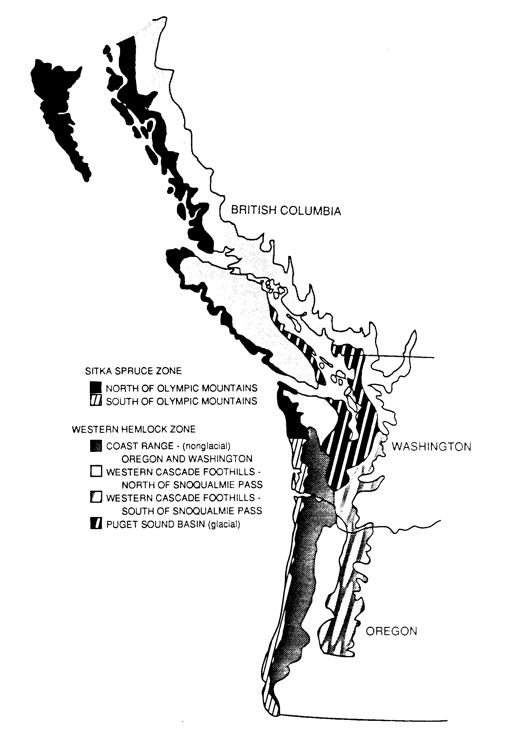

Figure 1. Climate/physiographic regions in the Pacific Northwest (adapted from Franklin and Dyrness 1969 and B.C. Bio-geoclimatic regional classifications).
2.1.2 Stocking and composition
Type 1 treatments are shown in Table 1. Initial stand density must exceed 1605 trees/hectare (650 tpa) for control plots and plots with a re-spacing at 6.1 m (20 ft.) HLC (treatments 1-6). For plots with a re-spacing at 9.8 m (30 ft) to HLC (treatments 7-9), initial density must exceed 717 tph (290 tpa). Estimates of initial stand density should be made using a fixed area plot sampling design.

Table 1. Type 1/thinned natural alder stand treatments.
__________________________________________________________________________
Age or Re-Spacing
Height-to-Live Density
Treatment Composition Crown at Entry tph (tpa)*
_______________________________________________________________________

104 4.6-6.1 m (15-20') 568 (230)
105 4.6-6.1 m (15-20') 1297 (525)
106 4.6-6.1 m (15-20') control
107 9.1-9.8 m (30-32') 247 (100)
108 9.1-9.8 m (30-32') 568 (230)
109 9.1-9.8 m (30-32') control
_________________________________________________________________________
*tph = trees/hectare, tpa = trees/acre

Trees must be well distributed throughout the stand and red alder basal area must be at least 90% of the total. Suppressed conifers in the understory ("regeneration failure") are acceptable in some situations.
Stand age must also be uniform (i.e., even-aged within 2 years) throughout a potential installation area. Total age must be determined from increment cores or stump counts on trees well distributed over a range of sizes.

2.1.3 Site index class
Site Index class (red alder 20 years [Harrington and Curtis, 1986], red alder 50 years [Worthington et. al., 1960]; see Figure 2a and 2b) should be determined for prospective study installations from previous or current site-specific inventory data. If adequate height/age data cannot be obtained for the site, data from comparable adjacent stands may be used. The comparability of adjacent sites should be assessed using plant indicators, soil characteristics, Douglas-fir site index, aspect, slope, slope position, and any other factors relating to site quality. If site index is to be determined from new measurements, select site trees on the basis of diameter (i.e., 10 of the largest trees per hectare). Site trees should also be well distributed in the stand, especially with respect to environmental gradients (e.g., lower slope vs. upper slope). If no suitable alder is present for site index estimation, use alder site evaluation guide based on Harrington and Curtis, 1986 (Appendix F).

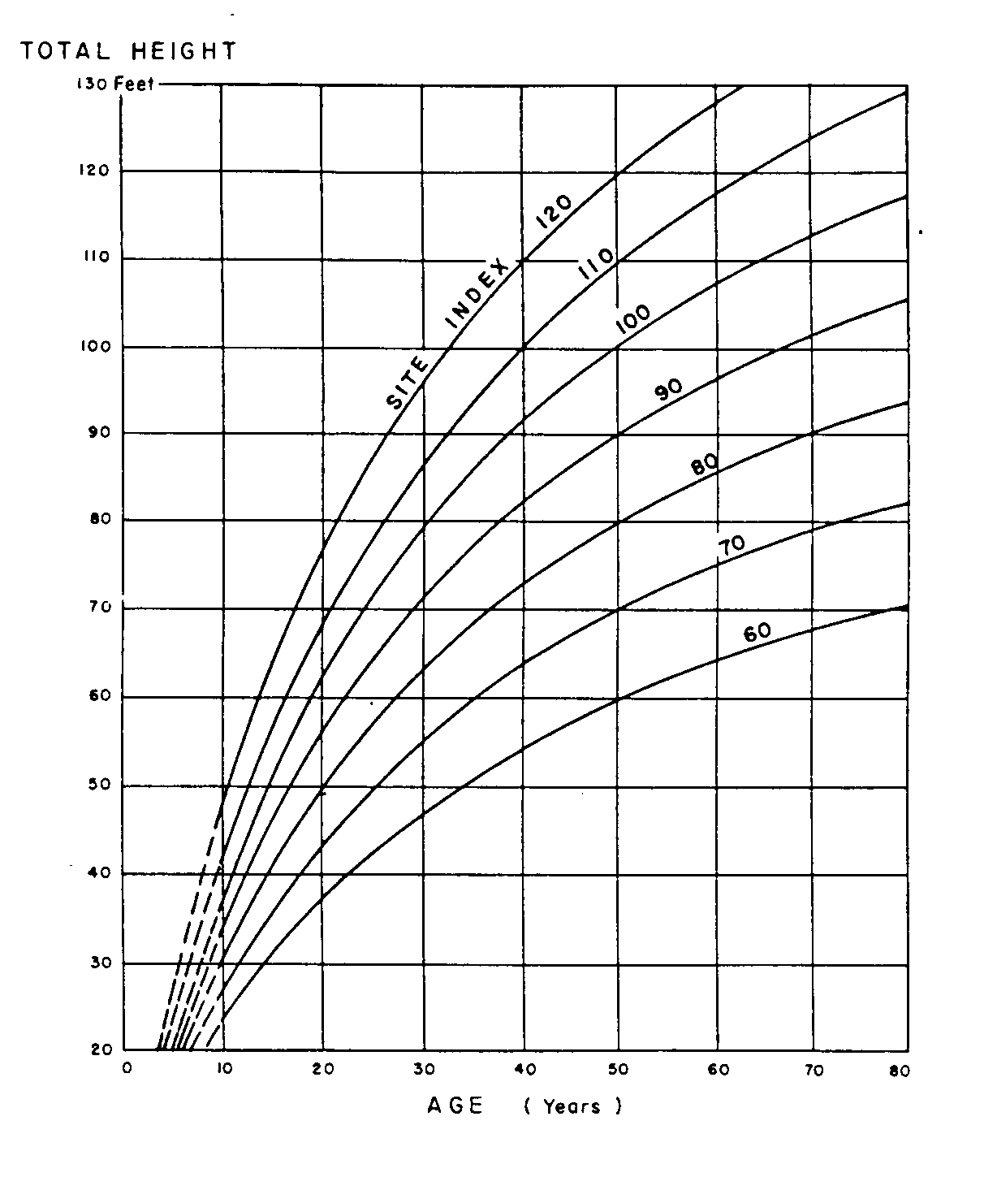

Figure 2a. Average total height of dominant and codominant trees. SI₅₀ curves from Worthington et al. (1960).

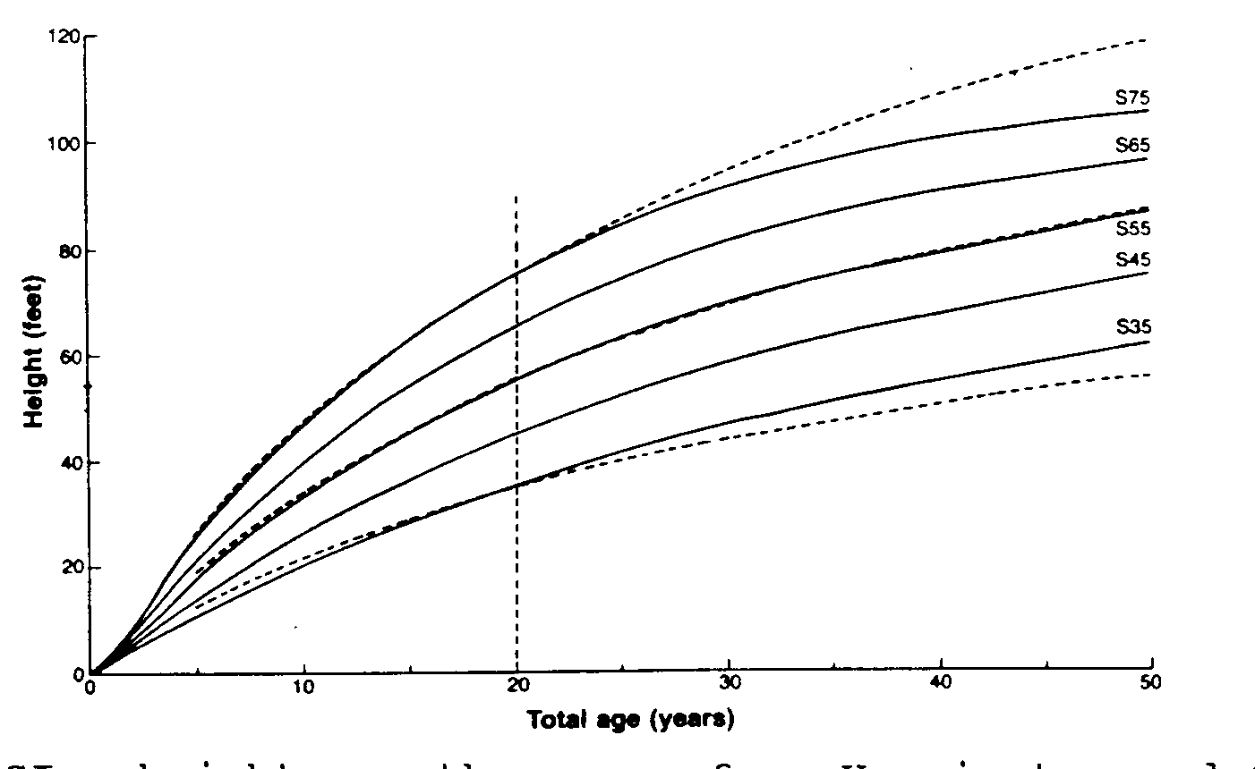

Figure 2b. SI₂₀ height growth curves from Harrington and Curtis (1986). Dotted curves are plotted from the equation given in Johnson and Worthington (1963).
2.1.4 Stand Uniformity
Our goal is to achieve uniformity and comparability among plots within an installation in regards to aspect, slope, plant association, stocking, site class, etc. Uniformity and comparability are relative terms. The magnitude and significance of variability differs between regions (e.g. a change from mid-slope to lower-slope may affect growth much more in the South Cascades compared to the Olympic Spruce Zone).

The objective is to incorporate a similar range of site variation in each plot and avoid significant gradients between plots in an installation. Within a prospective site, areas of relative extremes (wet, dry, rocky, steep, understocked, etc., beyond the typical range for the site) should be excluded.

2.2 Plot layout and documentation procedure
2.2.1 Plot location
A unit is acceptable if more than 80% of the area meets stocking and uniformity criteria (outlined above), and is big enough for all plots. Once a unit is accepted, select one or more baseline azimuth(s) to cover the unit such that potential plots can be laid out on one or both sides of a baseline. A Type 1 plot will require from 67.1 m (220.5 ft) to 76.3 m (250.5 ft) horizontal distance (i.e., slope corrected). Ideally, baselines should be perpendicular to directional gradients in site characteristics (generally parallel to contours). From the unit boundary, proceed on baseline a random distance (minimum 10m, maximum dependent on stand size). Evaluate the area according to selection criteria (Sec. 2.1). If the area fails to meet criteria, proceed another 10 m along baseline and try again. If the area is acceptable, set the first corner of a treatment plot (TP) on the baseline (see Section 2.2.2 for the definition of a TP). A Type 1 TP is 0.51 ha (1.27 ac), plot sides are 76.3 m (250.5 ft) on the long side and 67.1 m (220.5 ft) on the short side. Try to place the long dimension of the plot parallel to the baseline. Survey the boundaries of the entire plot. Proceed from the far boundary on the baseline and lay the next plot out immediately adjacent to the first. Continue in this manner until enough acceptable plots are installed for that installation.
Execution of this procedure will depend on individual site characteristics. With obvious departures from the selection criteria, individual plot evaluations will not require accurate traversing of plot boundaries and the 10 m intervals can be quickly traversed to reach better potential plot corners. A hypothetical example is shown in Figure 3a.

A more subjective and less systematic method of plot location may be needed to work in small and/or patchy alder stands. In this case, a thorough examination of the site must be performed to determine locations of individual plots. Stocking and uniformity criteria should be applied within and between small patches on a site.
Starting with the largest acceptable patch, lay out potential plots on a baseline that runs perpendicular to the most significant gradient in site characteristics. Proceed to the next nearest acceptable patch. In small stands, the orientation of plots may need to be carefully selected to fit within boundaries. Plots should be as contiguous as possible to facilitate field activities (see Figure 3b).

Figure 3a. Hypothetical plot layout for a Type 1 installation for a larger patch of acceptable alder (>80% acceptable by area).

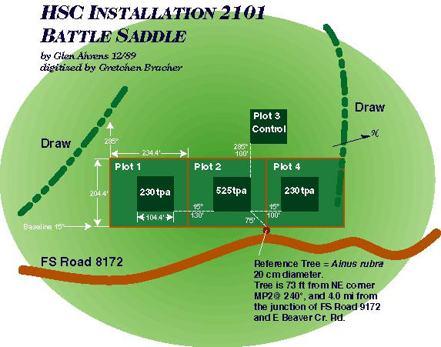

Figure 3b. Hypothetical plot layout for a Type 1 Installation with smaller patches of acceptable alder within a larger unit.
2.2.2 Surveying and marking
Type 1 plots consist of a 0.1 to 0.2 ha (0.25-0.5 acre) measurement plot (MP) with a 15 m (50 ft) buffer on all sides. An additional 9 m (30ft) of buffer is added to one side for later destructive sampling. The entire buffered plot is hereafter referred to as the TP (Figure 4).
The TP boundary should be surveyed using a steel or fiberglass tape and staff compass or right-angle prism using appropriate slope corrections (plot dimensions are horizontal distances). TP corners should be marked with orange (or pink) and blue flagging over a marker (steel, PVC or fiberglass posts), which is painted orange. True azimuths for boundaries must be recorded for use in construction of plot maps.

The preferred MP size is 0.133 ha (0.33 ac), which is 120.5 ft on a side and sits within the TP (Figure 4). If it is necessary to accommodate odd shaped areas or avoid understocked areas, the MP may be narrowed to a minimum of 100 ft on 2 sides, the other sides being elongated to achieve the desired 0.33-acre size. MP corners shall be set with permanent markers (i.e., steel, PVC, or fiberglass posts). Each MP corner post should have orange flagging and a metal tag scribed with plot number and the quadrant, written as NW, NE, SW, or SE. The "in" trees are flagged with orange ribbon while the survey tape is strung out for MP corner location (do not flag the actual boundary of the MP, only flag the “in” trees). Use the point where the tree enters the ground to determine "in" vs. "out" trees. For borderline trees, count every other one tree as "in". These trees can be painted after the block is fully surveyed in to make sure it closes. Trees on the MP/buffer boundary and inside the MP should be painted with an orange band (4-6 cm wide, neatly done) around the bole at DBH (138 cm or 4.5 ft).

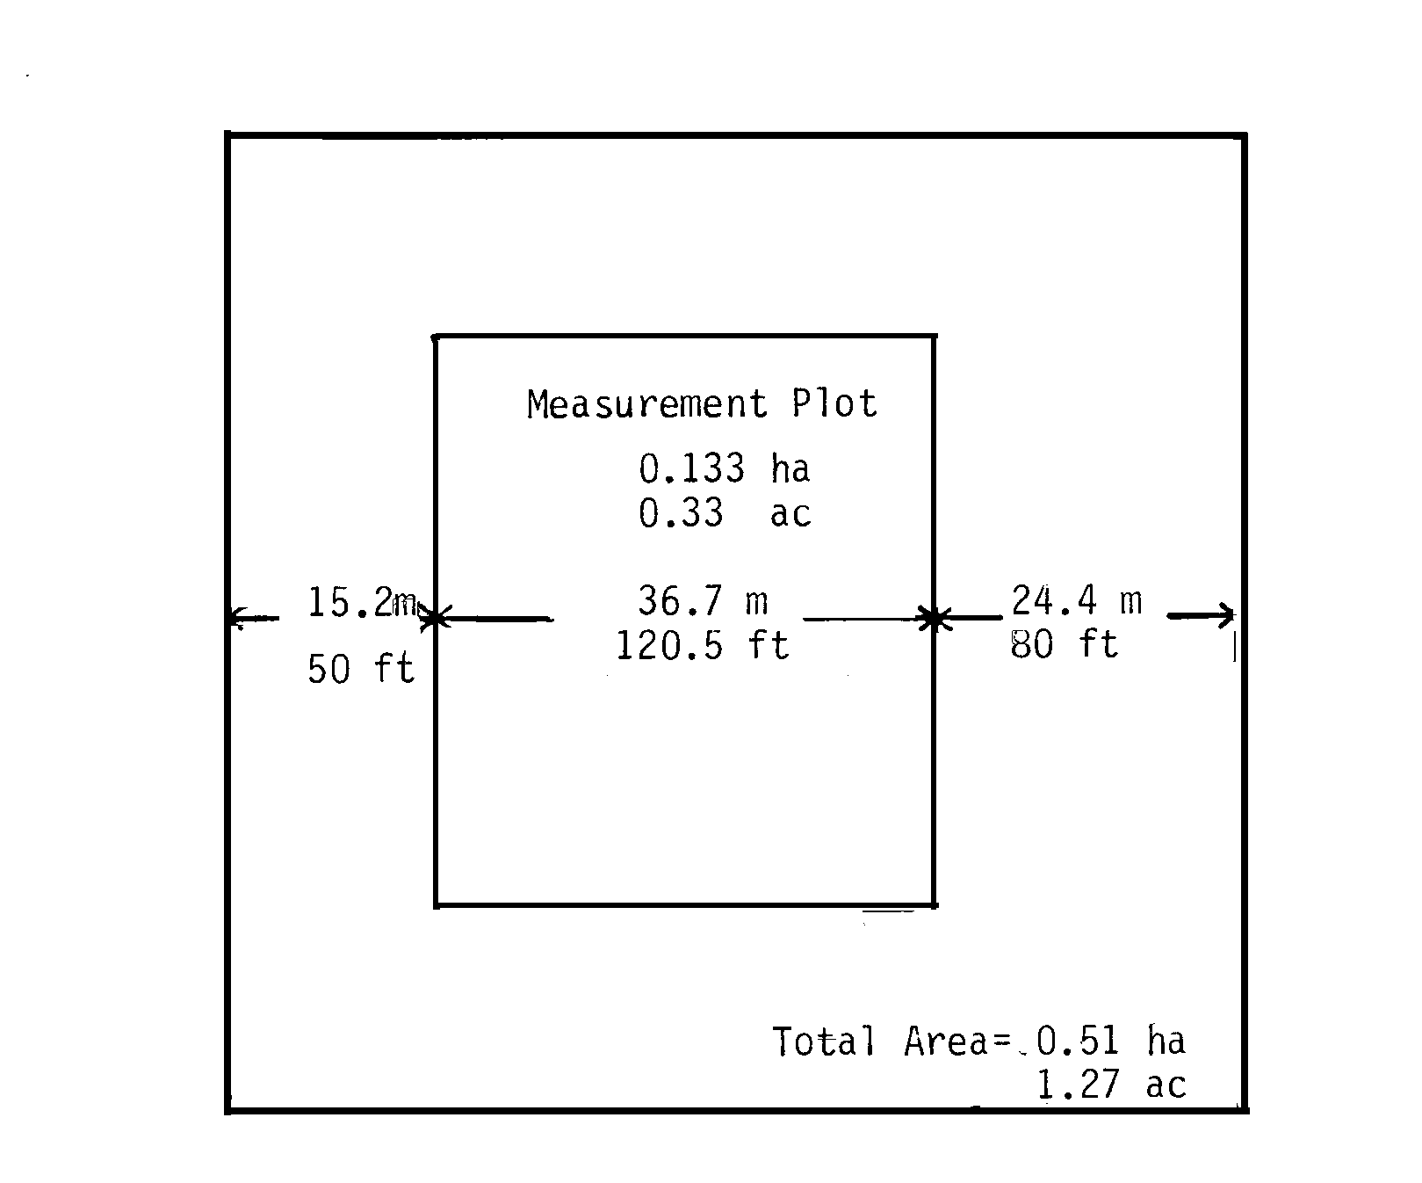

Figure 4. Typical Type 1 plot layout. Measurement plot and buffer= Treatment plot.

2.2.3 Plot referencing and mapping

Installations must be permanently located and referenced. Access maps should be drawn that allow easy relocation of stand units and plots within units (see Appendix A). Maps must include road access routes and distances from the nearest major intersections of permanent roads.
A MP corner of the plot nearest the road should be referenced (true azimuth and horizontal distance) to a permanent marker or tree (Reference point=RP) alongside the access road. Other plots in a unit will be referenced to the nearest corner of a previously referenced plot. All reference corners will be MP corners. If a plot is isolated from other plots it may be referenced to a new RP on the access road. Use your judgment to arrive at the best set of references for any installation. GPS all measurement plot corners if possible.
A detailed plot map shall be drawn showing access roads or trails, reference points, plot corners and boundaries, azimuths, and pertinent topographic features (see Appendix A). Distances and azimuths shall be shown on lines between reference points and reference corners. Reference markers should be described and any helpful comments noted. If possible, the installation should be marked on the most current aerial photograph with roads, reference points, and plot boundaries delineated. A photocopy of the aerial photo should go in the file with plot maps and establishment information sheets.

2.2.4 Signs, protection, and long-term planning
After all of the plots have been located and marked, the entire perimeter should be posted with "RESEARCH AREA" signs (provided by HSC). These signs should be stapled to tree trunks at frequent intervals to prevent trespass and damage to the research area.
Since installations are maintained until harvest, long- term plans and tentative termination dates should be documented. Landowners, managers, and field personnel must have detailed knowledge of the installation locations; every effort must be made to protect the site from inadvertent operational treatments not included in the study.

2.2.5 Stand establishment documentation
A completed stand establishment information sheet (Appendix B) must go on file in addition with the access and plot maps. HSC staff and pertinent cooperators should have copies of this file and all other records pertaining to an installation.

2.3 Spacing treatments
2.3.1 Treatment allocation
Treatments must be randomly allocated to plots after plot location and marking. Temporary flagging or other indicators should be laid out to clearly identify the different treatments for thinning crews.

2.3.2 Marking spacing treatments
Experience shows that self-thinning in alder occurs rapidly in dense stands. Inferior crown classes are easily suppressed and do not last long. Therefore, in addition to spacing, vigor and dominance are priority factors when selecting leave trees. Generally, the best trees at the nominal plot spacing are to be left. Table 3 shows nominal spacing and spacing tolerances for each treatment. Single stems are preferable to forked trees; however, forked trees may be selected if there are no other acceptable leave trees and all but the best stem is carefully removed during thinning.

Table 2. Nominal tree spacing and spacing tolerances for Type 1 installations.

Treatments Density Spacing Tolerance
___________________________________________________________________

107 247 tph 6.4 m 1.6 m
(100 tpa) 20.9 ft 5.2 ft)

104, 108 68 tph 4.2 m 1.0 m
(230 tpa) 13.8 ft 3.5 ft)

105 1297 tph 2.8 m 0.7 m
(525 tpa) 9.1 ft 2.3 ft)

106, 109 representative of typical stand condition at location
____________________________________________________________________

On plots to be thinned, locate plot boundaries and double- check the treatment label. Systematically traverse the measurement plot selecting leave trees. Designate leave trees with flagging around the bole at DBH or below (Appendix C). Use the following flagging colors: blue for 1297 tph, orange for 568 tph, and red/white stripe for 247 tph.
In thinned plots, other hardwoods such as bigleaf maple and cherry may be leave trees when there are no acceptable alder leave trees for that spacing. All conifers within the TP (including control treatments) are to be cut. Control plots are not to be thinned.

2.3.3 Tagging and pre-treatment measurements
A record of pre-treatment stand conditions is necessary. Initial measurements of control plots only are not adequate for comparison with thinnings. Initial diameter measurements are needed for all trees of any species in the MP (record on HSC Format 3, Appendix E, or preferably on an electronic data recorder).

Pre-treatment diameter measurements and the thinning treatment should be done during the dormant season, from mid-September to April 1. If thinning cannot be done in the dormant season, diameters on all leave trees will have to be remeasured in the dormant season following thinning. The order of tasks for a thinning treatment is described in Table 3.

Table 3. Order of Type 1 thinning treatment tasks performed in the growing vs. dormant season.
_____________________________________________________________________________
Thinned during growing season Thinned during dormant season
_____________________________________________________________________________
1. Mark leave trees on the MP. 1. Mark leave trees on the MP.

2. Measure DBH on all trees on the 2. Measure DBH on all
MP; mark DBH location on all trees on the MP; mark DBH on
leave trees. and tag leave trees as you proceed, recording DBH by tree number.
3. Execute thinning.

4. Tag and remeasure all trees on 3. Select height sample trees
the MP during the next dormant and finish establishment
season. Select height sample measurements
trees and complete establishment
measurement plots after thinning 4. Execute thinning; inspect
to note damage to leave trees and
replace any damaged tags.
_____________________________________________________________________________

Thinning during the dormant season is the most efficient method. The recommended procedure for marking and tagging trees is as follows:

1. Divide the MP into sectors/corridors (Figure 5). Beginning in the northeast MP corner, proceed through the sector tagging leave trees and measuring DBH of all trees (See Appendix C for details on DBH location and marking rules).

2. With high initial densities (>2500 tph), diameters of CUT trees may be recorded by 1 cm diameter class (or in extreme cases by dot tally only) on pre-treatment data sheets. Record DBH of leave trees by number as they are tagged.

3. Tag the leave trees with prenumbered tags, in sequence if possible. The tagging method for this study (ref. Weyerhaeuser Co. research) uses 11-inch plastic barlocks, staple gun, and 0.5 inch staples. Thread the barlock through the tag, pulling the tag to the end of the barlock. Hold the face of the tag against the tree bole with the barlock “tail” hanging vertically down. Staple the barlock exactly 5 cm above DBH (this will help identify where DBH is in case rain prevents painting or the DBH marks are otherwise lost). Leave about 2 cm of “tail” below the staple. Take care to ensure that the staples are fully driven and hold the barlock tightly against the bole. For trees less than 3 cm DBH, staple the barlock 15 cm above the ground (see Appendix D). Another method of tagging trees less than 3 cm DBH, is to thread the tag on the barlock and cinch the barlock/tag around a living branch.

4. Tag all trees in the control plots. For trees forked below DBH, tag each individual stem, in sequence. Treat trees forked above DBH as a single tree. Note: to facilitate the tagging/measuring, trees are generally tagged in clusters of 5. Therefore, trees are rarely in perfect sequential order within a sector/corridor.

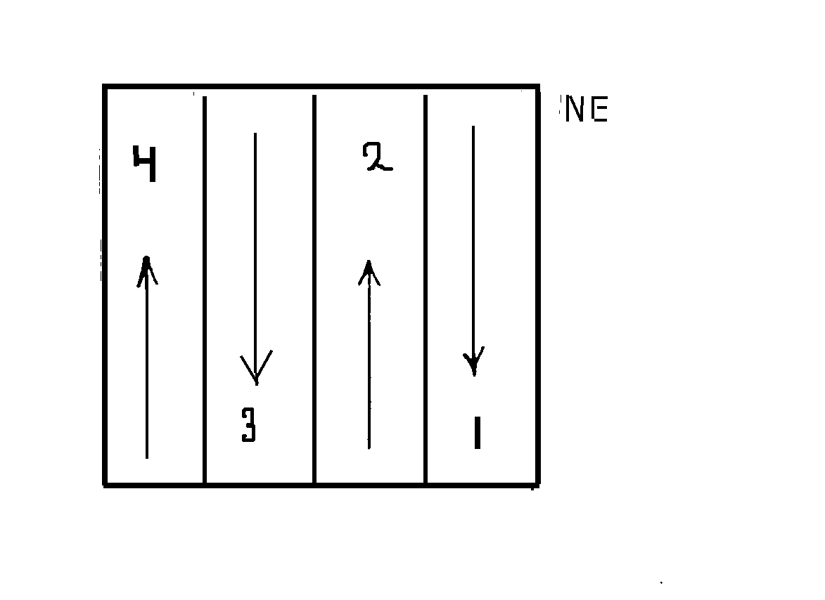

Figure 5. Example of dividing a MP into sectors/corridors.

2.3.4 Cutting
Thinners must be instructed NOT to cut any tagged or flagged trees. Care must be taken during thinning to:
1. not leave any trees hanging;
2. not damage any leave trees;
3. not miss any live branches or sprouts near ground level on CUT trees, and
4. To buck all slash to within 60 cm of the ground.
Instruct thinning crews to begin cutting in the marked MP to calibrate their eye to the spacing level for that treatment. From the MP boundaries, continue thinning at the "calibrated" spacing out to the TP boundaries.

2.4 Data collection and installation maintenance
2.4.1 Establishment data collection
Regardless of the season of establishment, data must be collected on tagged trees during the dormant season after thinning. Measurements are detailed in section 2.4.2. If thinning is done during the growing season, the entire set of measurements will have to be made on the MP during the dormant season. In either case, a complete set of data showing the actual post-thinning condition of trees on the MP must be obtained.

2.4.2 Measurements

Provide the field crews with adequate copies of plot forms and coding instructions (see Appendix E). The use of an electronic data logger is also encouraged. If used, the format and coding must be the same as shown on the forms in Appendix E. The same form is used for establishment and remeasurement. The preferred system of measure is metric. It is very important to note the system of measure (i.e., metric or english) used and to use the same system for all measurements. English measurements will be converted to metric when entered into the OSU database by the HSC staff. Measurements and procedures are described below:

DBH. Using a diameter tape, measure to the nearest 0.1 cm (or 0.1 inch) directly above the DBH paint mark (134 cm). Measure DBH on all tagged trees in the MP. For rules on locating and marking DBH, refer to Appendix C.

Total height . Measure to nearest 0.1 m (or 1.0 ft) all trees on the MP or for a subsample of at least 40 trees when there are more than 40 trees on the MP. The subsample should be spatially well-distributed over the plot and cover the 10 smallest DBH trees, the 10 largest DBH trees, and 20 trees in the mid-range. Complete the following to ensure that the 40 sample trees are evenly distributed over the range of diameters on each plot:
Categorize tree numbers into 2.5 cm (1 inch) diameter classes as diameters are measured. After about 10 trees, the mid-range of the diameter distribution for the plot becomes apparent. As you continue through the plot take heights of trees that are above or below that mid-range as you come to them. Be careful to ensure that sample trees are well dispersed throughout the plot. For example, if 2/3 of the plot has been measured then approximately 7 small and 7 large and 14 mid-diameter height trees should be recorded. If more than 7 small diameter trees are recorded, then only take heights on trees 1 or 2 diameter classes from the smallest recorded tree. If a tagged tree is 2 diameter classes (5 cm) smaller (or larger), than any tree already recorded, measure the height (regardless of the quota). The middle of the distribution is filled in by randomly selecting trees with a mid-sized diameter as you proceed through the plot. This method only requires one pass through the plot, however, strict attention must be paid not to clump sample trees in diameter classes.

Height to live crown (HLC). HLC is the distance from the ground to the base of the live crown. The base of the live crown is defined as the lowest point on the bole with live branches that originate in at least three quadrants (exclusive of epicormic branching). Although alder branches do not originate in true whorls, there is generally a nodal concentration of branches. HLC is measured where the quadrants, or faces within such a group of branches joins the bole. Measure HLC to the nearest 0.1 m (or 1.0 ft) for the subsample of tagged trees selected for total height measurement.

Fork. Record the incidence of forking. For trees forked below DBH, use the code X1, where X = the total number of stems in the group, including the one selected for saving. Trees forked above DBH are coded 01, regardless of the number of forks.

Lean. Measure and record the angle of lean, in degrees, for trees leaning more than 10 degrees.

Deviation (DEV). Record the existence and severity of stem sweep as follows. For the 8 ft butt log (1 to 9 feet off of the ground), record the maximum distance, in inches, between the bole and a straight pole touching the tree at the 1 and 9 foot heights, regardless of lean.

Condition (COND). A three digit code designates dead and damaged trees, with room for two general causal agents:
First digit: 1 = damaged
2 = dead

Second and third digits: 1= epicormic branching
2 = weather/other environmental
3 = animal damage

4 = human damage
5 = insect damage
6 = disease
7 = unknown
9 = suppression

Comments (COMM). Use this column to indicate or describe any other environmental or biological condition, which may affect the growth performance/survival of a tree. For example, use the comments section to give a more specific cause of damage or condition (such as "rub" or "browse" if there is animal damage, or "broken top" following environmental damage), or, in the case of bole disease, the characteristics of infection. The following are some examples of bole disease (may use more than one):
1. Sooty appearance on bole
2. Red blisters on the bole
3. Rough and black around knots and branch stubs
4. Death of cambium (cankers)

2.4.3 Remeasurement and plot maintenance
The measurement interval will be 3 years through year 9, after which the plots will be remeasured every 5 years. Prior to remeasurement, notify the HSC staff and request copies of the pertinent data forms. The HSC staff will run computer programs to print site-specific data forms including data from the previous sample. These data include plot identification and description items, tree numbers, tree history codes, diameters, and heights. Possessing the previous measurements facilitates quick field comparisons of measurements and the identification of potential errors and missing tree tags.

During remeasurement, look for any untagged trees in the MP. When missing tags occur, every effort should be made to identify and re-tag these trees with the original number. Tag and assign new numbers to untagged trees only after ascertaining that there are no missing tags in that sector/corridor (i.e., you might find the “missing” tree later). Sequential numbering of trees is of great value in this case.

The following plot maintenance actions should be taken at remeasurement:
1. Check barlock/tags and replace or reset those that are missing or damaged.
2. Install barlock/tag at DBH on trees that have attained minimum DBH or relocate the tag from a branch to the bole.
3. Repaint reference trees.
4. Reset and repaint MP corners.
5. Replace flagging for access trails, plot corners, etc.
6. Repaint plot boundary trees.

2.4.4 Destructive sampling in wide buffer strip
The wide buffer strips are established to accommodate future destructive sampling for characteristics such as stem taper and wood quality. These activities are not included in this study plan. A study plan for destructive sampling will be developed as part of a separate project.

2.4.5 Product recovery monitoring

Since wood quality (especially percentage recovery of "Select" grade lumber) is a major factor in the value of the alder resource, spacing levels should be evaluated in terms of volume recovery by lumber grade. When the installations are finally harvested, logs from each plot should be kept in separate batches to allow determination of product recovery by treatment. Since the harvest will be done when the installations are approximately 25-35 years old, details of such monitoring will be developed for the technology of that time.

3. TYPE 2 /ALDER VARIABLE DENSITY PLANTATIONS
Type 2 installations examine the spacing effects in alder plantations established at a range of spacings, and with re-spacing at various ages. These installations will be established on recently harvested sites (i.e., clearcuts), stratified by region and site class.

3.1 Site selection
3.1.1 General considerations
The sampling matrix for Type 2 plantations is shown in Table 4. Most regions cover a wide latitude and where replication occurs within a site class and region, one replication should be toward the north end of the region and the other should be toward the south end of the region. The site preparation methods used should be the standard operation methods for the region and should include normal competition reduction practices; broadcast burning is preferred. Since plantations will be maintained until final harvest (25-35 years), the capability for long-term protection and maintenance is a requirement for prospective sites.

3.1.2 Unit size
Type 2 installations will require 6-8 ha (15-20 acres) of reasonably uniform and comparable ground. Depending on the nature of a specific site, a much larger unit size may be required to allow for the exclusion of unsuitable areas. For example, in more steep, rocky areas, prospective units may need to be as large as 16-24 ha (40-60 acres) in order to find enough ground suitable for plots.

Table 4. Sampling matrix for Type 2 plantation establishment. The table shows the number of installations by site index class and climate/physiographic regions.
_________________________________________________________________________
Site Index Class (SI₅₀) *
23 - 27 m 28 - 32 m >32 m
Region 75 - 90 ft 91 - 105 ft >105 ft Total
________________________________________________________________________
Sitka Spruce, N. of - 1 2 3
Gray's Harbor

Sitka Spruce, S. of 2 2 2 6
Gray's Harbor

Coast Range 2 4 3 9

Cascades, N. of 1 3 1 5
Snoqualmie Pass

Cascades, S. of 1 2 - 3
Snoqualmie Pass
________________________________________________________________________
Total 6 12 8 26

* Worthington et. al. (1960). Corresponding SI₂₀ (Harrington and Curtis 1986) classes are 14-17 (45-55 ft) 17-20 ( 55-65 ft), and >20 (>65 ft).

3.1.3 Site index class

Site Index class (alder 20 years, Harrington and Curtis (1986); alder 50 years, Worthington et. al. (1960) should be determined for prospective units (see Figure 2). Whenever possible, the site index class should be determined from measurements on suitable alder on, or adjacent to, the prospective unit before harvesting. The comparability of adjacent sites should be assessed using plant indicators, soil characteristics, aspect, slope, slope position, and any other factors relating to site quality. When there is no suitable alder present for site index estimation, use the alder site evaluation guide developed by Harrington (1986), to estimate site index for the placement of a site in the sampling matrix (see Appendix F).

3.1.4 Site uniformity and mortality hazards
The main goal of plantation establishment is to achieve comparability and uniformity among and within planting blocks. Whenever possible, the site should be examined before and after harvesting the previous stand. This allows assessment of both pre- and post-harvest vegetation indicators along with other post-harvest impacts on the site.
Knowledge of the conditions of the previous stand also allows for a better evaluation of the suitability of the site for alder establishment. Experience with planting alder in the different regions has shown a wide variation in survival. Significant mortality from various combinations of frost, drought, flooding, insects, and animals has been common. While certain regions and site index classes in our sampling matrix make some hazards a likely occurrence, prevention or avoidance of known hazards is still a priority. This is why it is important to have the landowner fill out the Stand Establishment Information Sheet (Appendix B). For example, beaver and mountain beaver have been significant mortality agents in some past alder plantation experiments. The need for prevention (trapping), protection (vexar or fencing), or avoidance must be considered if there are populations of these animals within the range of a prospective site.

3.2 Planting block establishment procedures
3.2.1 Planting block layout and delineation

Treatments for Type 2 installations are shown in Table 5. Be sure to note that the planting blocks are planted 20% denser than the final desired density to account for expected mortality. This higher density will be referred to as the "planting density" and the desired final density as the "target density". Initial planting densities for each treatment will be established in the planting blocks. The minimum size for planting blocks is 0.6 ha (1.5 acres).
The 1556 and 3558 tph (630 and 1440 tpa) planting densities each require blocks large enough to accommodate four 0.5 ha (1.3 acre) treatment plots (Figure 4, Sec. 2.2.2). The 682 tph (276 tpa) planting density requires space for two TPs and the 296 tph (120 tpa) planting density requires space for one TP. If possible, the 296 tph (120 tpa) planting block should be large enough to accommodate a larger measurement plot (0.2 ha [0.5 ac] vs. 0.13 ha [0.33 ac], and thus a corresponding larger treatment plot (84 x 76 m [280 x 250 ft] vs 76 x 67 m [250 x 220 ft]). This larger plot ensures an adequate sample size. If necessary, each TP may be established in a separate planting block.

Table 5. Type 2/alder variable density plantation treatments.
____________________________________________________________________
Re-Spacing
Target Planting
Density Density Age or HBC Density
Treatment tph(tpa) tph (tpa) tph(tpa) Other
_________________________________________________________________________
1 247 296 control -
(100) (120)
2 568 682 control -
(230) (276)
3 568 682 - - Prune
(230) (276)
4 1297 1556 control -
(525) (630)
5 1297 1556 3-5 yrs 568
(525) (630) (230)
6 1297 1556 4.6-6.1 m 568
(525) (630) (15-20') (230)
7 1297 1556 9.1-9.8 m 568
(525) (630) (30-32') (230)
8 2965 3558 control
(1200) (1440)
9 2965 3558 3-5 y 568
(1200) (1440) (230)
10 2965 3558 4.6-6.1 m 568
(1200) (1440) (15-20') (230)
12 2965 3558 4.6-6.1 m 247
(1200) (1440) (15-20') (100)
________________________________________________________________________

Harvested units of 6-8 ha will have substantial environmental variation. Extreme variation and systematic bias within the unit should be avoided. Similar to layout guides for Type 1 installations, the long axis of each Type 2 planting block should run perpendicular to identifiable site gradients. Try to attain similar within-block ranges of variation while minimizing trends in site character between blocks.
Make a detailed inspection of the prospective site and prepare an accurate large-scale map (preferably with contours) showing unit boundaries and salient features such as unacceptable areas, vegetation type boundaries, directions of obvious site gradients, etc. (This map will provide the basis for future plot maps as required in Sec. 3.2.3.). Divide the acceptable area within the unit into logical planting blocks for each planting density, large enough to accommodate buffered treatment plots. A TP is 76 x 67 m (250 x 220 ft). Scaled drawings of treatment plot perimeters on acetate may be overlaid on the large scale unit map to help determine the approximate block boundaries. An example of a Type 2 installation map with planting block boundaries is shown in Appendix A.
After a satisfactory array of approximate block boundaries is visualized, survey the block boundaries with a staff compass and tape or string box. Initially, corners and boundary lines may be marked with temporary pin flags. Before planting, the blocks must be clearly and permanently marked with metal or PVC posts painted blue and flagged blue. Planting block number and planting density should be written on metal tags attached to corner markers facing the inside of the block. Flag the boundary lines as necessary to make them obvious to the planting crews. The amount and spacing of the flagging will vary with the terrain and the amount of brush and slash on the site. Flagging adjacent blocks with a different color may help crews distinguish between blocks.

3.2.2 Initial spacing and re-spacing treatment allocation

Target densities should be randomly allocated to planting blocks. Respacing treatments should then be randomly allocated among all potential plots within a given target density. TPs will be located within planting blocks after successful plantation establishment (determined after 2 years).

3.2.3 Planting block referencing and mapping
Planting blocks must be numbered, clearly mapped, and referenced for future access. Permanent reference markers at logical access points should be marked and mapped as for Type 1 installations (Sec. 2.2.3). Azimuth and distance to suitable reference corners must be measured and recorded for each planting block. As the installation is established, additional information such as planting density, measurement plot boundaries, measurement plot reference information, access trails, etc. should be added to the map. On planting maps, be sure to use planting density (120% of target density, see Table 4) to avoid confusing planters and inspectors. A sample Type 2 installation map is shown in Appendix A.

3.2.4 Seed collection and seedling culture
If actual planting block areas are not known at the time of sowing for nursery production, a minimum sowing request for 15,000 seedlings is recommended. A minimum figure of 12,000 seedlings is obtained from calculations based on the minimum area of 6 ha (Sec. 3.1.2). Actual seedling requirements depend on the planting block layout for a given site; they will generally exceed the 12,000 minimum due to irregular block boundaries in the field.

The need for adequate seed for seedling production and seeding treatments must be anticipated for each prospective installation. The amount of alder "cones" required to obtain adequate seed depends on the following variable factors: amount of seed per bushel of cones, seed viability (germination rate), nursery establishment rate, and seedling cull rate. Before collecting seed, consult with HSC Staff and use guidelines established in "Red alder: Guidelines for seed collection, handling, and storage" (Hibbs and Ager 1989). Seed must be collected early enough so that the seedlings are available for planting the first spring after site preparation.
The "target" alder seedling for these installations has the following characteristics:
1) Height from 30 to 75 cm (12-36 inches).
2) Caliper or basal diameter of at least 4 mm.
3) Branches or large buds along the entire length of the stem.
4) Frankia nodules on the roots so the seedlings can effectively fix nitrogen.
5) Full, unbroken root system.
The relative size of seedlings in a planting bed should also be considered, particularly if the seedlings are crowded. Seedlings that meet the minimum size of 4 mm X 30 cm may still be of marginal quality if they were grown in a crowd of larger seedlings. Diameter is more important than height; stocky seedlings are much better than tall thin ones. The ratio of height to diameter (cm height/cm diameter) is a good diagnostic characteristic: ratios less than 100 are preferred; 60-70 is optimal.
Quality stock may be produced with open-bed nursery culture of bare root stock from direct seeding or from transplanted greenhouse plugs. Low seedling densities in the nursery beds will allow the development of lower branches and buds. Although fertilization and irrigation may help with uniform establishment in the nursery, excessive height growth and succulence must be avoided. Open-bed bare root seedlings are preferred. The best are plug transplants, where seed is sown in small containers and outplanted into open beds in June or July. This results in stocky seedlings with full root systems and optimal bed density for maintaining leaves and branches along the entire stem.

The need for root nodulation cannot be overemphasized. If Frankia nodules are not present there will be little seedling growth in the first year, putting the seedlings at a competitive disadvantage. Some nurseries are reluctant to inoculate the beds with Frankia, which is the only way to ensure nodulation. If alder is planted in the same area every year, and the beds not fumigated, nodulation is likely, but it is best to avoid nurseries that will not inoculate.
Seedlings should be lifted in January and stored at -2ºC (28ºF) until out planting between March 15 and April 15. Ideally, the planting date should be chosen to minimize potential for frost after bud-break, while maximizing the period of favorable soil moisture for root growth before any summer drought. Where early drought or late snow are limitations, a November planting date may be best to ensure adequate early root growth the following season.
Detailed guidelines for seedling production and out planting are also given in "Red alder - guidelines for successful regeneration" (Ahrens, Dobkowski, and Hibbs 1991).

3.2.5 Plantation establishment
Planting crews should be provided with maps showing the location of blocks within a unit and the planting densities. A knowledgeable supervisor (HSC staff or Cooperator) should meet with the planting crews for pre-planting instruction and subsequently monitor planting quality and density. Double check plot numbers and densities on the map and in the field before planting each block. Planting densities, spacing and tolerances are shown in Table 6.
Specific recommendations for planting alder are:
1. Plant seedlings deeply (bury root collar 1 inch or more) using a shovel to open a planting hole.
2. Take special care not to injure stems during all stages: avoid touching stem with boot when packing soil around seedlings.
3. Do not scalp the planting spot more than required to open an adequate hole.
4. Take special care to avoid warm temperatures during planting and around seedling bags stored on the site.

Table 6. Planting densities, tree spacing, and tolerances for Type 2 (plantation) installations.
______________________________________________________________________
Treatments Planting Density Spacing Tolerance^{b}
tph (tpa)ª m (ft) m (ft) ______________________________________________________________________
1 296 (120) 5.8 (19.1) .9 (2.9)
2, 3 682 (276) 3.8 (12.6) .6 (1.9)
4, 5, 6, 7 1556 (630) 2.5 (8.3) .4 (1.3)
8, 9, 10 3558 (1440) 1.7 (5.5) .26 (.8)
___________________________________________________________________
a) tpa=trees/acre, tph=trees/hectare
b) In addition to the spacing tolerance, total density (tph or tpa) should be within 10% of the planting density.

The average height and stem diameter for planting stock should be determined from a sample of at least 25 seedlings. Measure stem diameter to the nearest 0.1 mm, 1 cm above the root collar. Measure stem height from the root collar to the base of terminal bud on the dominant leader. Record these measurements on HSC Format 8 (Appendix E).
Planting crews should be closely supervised to ensure planting quality and spacing control. Keep crews close together and plant one density (block) at a time. In order to calibrate the crew to each spacing, have each planter measure out the spacing until they are able to consistently meet the specifications by eye. For the closer spacings, precut lengths of wood or plastic pipe are helpful for initial calibration.

Maintaining spacing is especially difficult with alder because seedlings are difficult to see after planting (scalping helps with visibility but it is not recommended because it increases damage from exposure). Keeping the crew close together helps solve this problem. Marking planted spots with pin flags may be helpful if poor visibility is an extreme problem. Seedlings should not be marked with paint unless the paint has been proven to be non-toxic to alder. Do not tie any flagging around the main-stem of seedlings.
In sites where large amounts of salmonberry or other vegetative competition will necessitate manual release after planting (where pre-plant herbicide treatments are not an option), it is important to mark the trees at the time of planting, as they will be very difficult to find during the summer. Each planter should carry a bundle of pin flags or bamboo stakes and flagging to mark the trees as they plant.

3.2.6 Post-planting monitoring plots
Plantation performance will be monitored using 5.1 m (16.7 ft) radius circular plots established immediately after planting. Larger, 7.18 m (23.6 ft) radius plots may be used on the widest spacing (296 tph [120 tpa]), and smaller 3.6 meter (11.8 ft) radius plots should be used in the closest spacing (3558 tph [1440 tpa]). These same plots can be used for monitoring and controlling spacing and planting quality during the planting job. Systematically locate plots on a 30 x 30 m grid (100 x 100 ft) in all planting blocks, making sure to have at least 5 plots per treatment block (individual treatment blocks usually end up with 4 plots on the 30 meter grid, with the 5th plot in the center). Mark the location of each planted seedling in the plot with a stake-flag and record the number of seedlings in each plot. Number plots sequentially for the entire installation and mark the plot centers with numbered cedar stakes and flagging or a different colored stake flag. Also mark plot locations on detailed block maps.

3.2.7 Signs, protection, and long-term planning

After planting is complete the entire area should be surrounded by "RESEARCH AREA" signs (provided by HSC). These should be posted at frequent intervals to prevent trespass and damage to research areas. Since installations will be maintained until harvest, long-term plans should be documented along with tentative termination dates. Landowners, managers, and applicable field personnel must have detailed knowledge of installation locations; every effort must be made to protect the site from inadvertent operational treatments not included in this study.
Volunteer alder or cottonwood seedlings are a likely occurrence, especially in low density planting blocks. All invading trees and any overtopping shrubs must be controlled. This may require labor-intensive manual treatments during the first 2 years of plantation establishment. Great care must be taken to protect planted trees and maintain proper spacing during any weeding treatments. It may be necessary to mark planted trees with flagging or non-toxic paint. Do not tie flagging around the main stem of young alder, as they grow quickly and can be constricted.
The establishment period is especially crucial. The effort required to anticipate and prevent mortality from various agents may be much greater than operational situations would allow. Such effort might include the use of shade cards on harsher sites, trapping of animals and/or the use of animal repellants. This effort is necessary because the objective of the study is to quantify the responses of trees at different spacings, not to evaluate various mortality agents and establishment obstacles.

3.2.8 Stand establishment documentation
Each landowner or manager should complete the stand establishment information sheet for their site (Appendix B). After completion, send a copy to the HSC staff at the Department of Forest Science, Oregon State University, Corvallis, Oregon 97331.

3.3 Data collection and installation maintenance
3.3.1 Plantation evaluation, initial measurements, and MP installation
Year 1 evaluation: After the first growing season, seedling survival and size should be evaluated in each planting block. Relocate the monitoring plot centers installed at planting and inventory the planting spots marked by stake-flags. If monitoring plots are not found then establish new plots by the method explained in section 3.2.6. There should be 50 monitor plots per installation, equaling 5 plots per treatment block.
Using the Plantation Monitoring Datasheet (Format 5, Appendix E), record the planting block number and monitoring plot number for each marked planting spot on the sample plot. For live seedlings record HT (to cm or inch), NODE (point at which the current year's growth began, to cm or inch), and COND (see Appendix E for condition codes). For missing seedlings record as dead in COND. For each sample plot, note under COMMENTS any apparent causes of mortality, and any other important characteristics affecting seedling environment. In addition, estimate the maximum height and percent cover for competing vegetation within the radius of the survival plot. Record this information in the COMMENTS column of the seedling database or on a separate sheet of paper. Make general observations of planting block conditions, and indicate on the site map any problem areas due to animals, frost, drought, etc. Record natural alder and other tree regeneration by species to guide prescription of weeding treatments.
Send copies of the data, maps, and other observations to HSC staff for review before the next growing season. In cooperation with HSC staff, the status of the installation will be evaluated prior to continued sampling and maintenance.
Year 2 evaluation: After the second growing season, locate the sample plot centers from the previous year, complete another Plantation Monitoring Datasheet (Format 5, Appendix E) and repeat the overall evaluation of planting blocks as in Year 1. Review and mail the results to the HSC staff.

Determination of establishment: The Year 2 evaluation results will be used to determine whether the plantation is successfully established. This determination will depend on the extent and distribution of mortality and damage. In general, the plantation is considered to be established if mortality does not exceed 30% within potential measurement plot locations in each planting block. HSC Staff will make the final determination of establishment.

MP location, delineation, and treatment allocation: After the determination of establishment and before 3rd year measurements, survey and mark the measurement plot (MP) boundaries (as in Sec. 2.2.2, Figure 4) within each planting block. There should be some room to avoid problem areas during the location of the MP. The preferred MP size is 0.133 ha (0.33 ac), which is 120.5 ft (slope corrected) on a side. A 15 m (50 feet) buffer surrounds the MP on three sides and a 24 m (80 ft) buffer on the fourth side. If it is necessary to accommodate odd shaped areas or avoid understocked areas, MP may be narrowed to a minimum of 100 feet on 2 sides, the other sides being elongated to achieve the desired 0.33 acre size. MP should be parallel to and on the same bearing as the planting block. A staff compass and survey tape is the best method to ensure 90º angles and straight lines. MP corners shall be set with permanent markers (steel, PVC, or fiberglass posts), and each post should have either orange or blue flagging and a metal tag scribed with MP number and quadrant (NW, NE, SW, SE). The "in" trees are flagged with orange ribbon while the survey tape is strung out for corner location. Use the point where the tree enters the ground to determine "in" vs. "out" trees. For borderline trees count every other one "in". These trees can be painted after the block is fully surveyed to make sure it closes. Trees on the MP/buffer boundary and inside the MP should be painted with an orange band (4-6 cm wide, neatly done) around the bole at diameter breast height (138 cm or 4.5 ft).

Reference the most convenient MP corner to a previously referenced point (i.e., planting block corner). MP’s are numbered as they are surveyed. Data management is facilitated when the MP number matches the treatment number that will be applied to the plot. For example; MP 2 and 3 should be in the 276 tpa planting block because treatment 2 and 3 occur in that density. However, number coordination is not always possible. Update the plot maps (Sec. 3.2.3, Appendix A) with MP boundary lines, reference distances, and azimuths. Send updated maps to HSC staff.

3.3.2 Post-establishment measurements, re-spacing, and remeasurement
Year 3 remeasurement:
The first measurement occurs on control plots (treatments 1, 2, 4, 8). Trees should be measured in the dormant season after the third growing season. Complete the following tasks at the Year 3 measurement:

Tagging trees: divide the MP into sectors/corridors (Sec. 2.3, Figure 5) and proceed through each sector/corridor tagging trees and recording measurements by tree number. Staple the barlock/tag to the bole of the tree, 5 cm (2 inches) above DBH (see Sec. 2.3.3 and Appendix D). If the DBH is too small, staple the tag anywhere possible on the bole, or tag the tree on a living lateral branch originating near DBH. Tags should be attached as loosely as possible, to allow for branch growth, but not so loose as to allow the wind to blow them off. Try to find a branch that has secondary branches that will prevent the tag from blowing off. If there are no such branches, and the tree is relatively small, place the cable tie loosely around the main stem, between some lateral branches to avoid blowing off. If it appears that the tree will outgrow the diameter of the cable tie in three years, pick a stout branch fairly high up, on the south side of the tree, that will be the most likely to survive 3 years until the next measurement, and cinch the cable tie tightly. This may kill the branch, but it is preferable to losing the tag.

Form Prune: Trees forked below DBH will have all but one selected stem removed. A fork is defined as a stem that is > 75% of the height of the tallest stem, and is within 20º of vertical at the tip. The criteria for stem selection are, in order of importance:
1) straightest stem in the clump, without forks and without defect severe enough to cause weakening of the stem. Note that this may not necessarily be the largest stem in the clump; quality is most important.
2) tallest stem in the clump.
3) stem on the south side of the clump, with crown facing south or southwest. This will protect the stem from sun scald after the other stems are removed.
4) stem with the largest diameter at breast height.

Form pruning is done in ALL plots/treatments. Tag and record data for only the stem selected to save, but make sure to record the original number of stems. Excess stems can be removed as they are being measured, or can be flagged for removal before the next growing season.

Data collection: Record DBH, HT, HLC, FORK, LEAN, DEV, and COND for all trees in the control MPs. Note that height and height-to-live crown are recorded for all trees in the 3rd year measurement only (for subsequent measurements, only a subsample of the trees are measured, see Sec. 2.4.2).
Record the data on the Plantation Remeasurement Datasheet (Format 7, Appendix E). HSC staff will provide field copies of this datasheet. The use of electronic data loggers is encouraged; however, the format and coding must be the same as Format 7. The preferred system of measure is metric. It is very important to note the system of measure (Metric/English) used and to use the same system for all measurements. Measurements and procedures are described below:

DBH- Measure by diameter tape to the nearest 0.1 cm (or 0.1 inch) at 134 cm (4.5 ft) on the uphill side of the tree (or, if present, directly above the DBH paint mark). DBH is measured on all trees in the MP. For rules on locating and marking DBH, refer to Appendix C.

Total height (HT)- Measure to nearest 0.1 m (or foot) for all trees in the MP. For the Year 3 measurements, heights will be less than 9 m and direct measurement with a laser, digital hypsometer or height pole is recommended.

Height to live crown (HLC)- HLC is the distance from the base of the tree to the base of the live crown. The base of the live crown is defined as the lowest point on the bole with live branches that originate in at least three quadrants (exclusive of epicormic branching). Although alder branches do not originate in true whorls, there is generally a nodal concentration of branches. HLC is measured where the quadrants, or faces within such a group of branches joins the bole. Measure HLC to the nearest 0.1 m (or foot) on all trees measured for total height.

Fork- Record the incidence of forking. For those trees forked below DBH, use the code X1, where X = the total number of stems in the group, including the one selected for saving. Trees forked above DBH are coded 01, regardless of the number of forks.

Lean- Measure and record the angle of lean (in degrees) for trees leaning more than 10 degrees from vertical.

Deviation (DEV)- Record the existence and severity of stem sweep. For the 8 ft butt log (1 to 9 feet off of the ground), record the maximum distance (in inches) between the bole and a straight pole touching the tree at the 1 and 9 foot heights, regardless of lean.

Condition (COND)- A three digit code designates dead and damaged trees, with room for two general causal agents:
First digit: 1 = damaged
2 = dead

Second and third digits: 1= epicormic branching
2 = weather/other environmental
3 = animal damage
4 = human damage
5 = insect damage
6 = disease
7 = unknown
9 = suppression

Comments (COMMENT)- Use this column to indicate or describe any other environmental or biological condition which may affect the growth performance/survival of a tree. For example, use the comments section to give a more specific cause of damage or condition (such as "rub" or "browse" if there is animal damage, or "broken top" following environmental damage), or, in the case of bole disease, the characteristics of infection. See Appendix E for examples of comment codes.

Miscellaneous- To evaluate the readiness for the 3-5 year re-spacing treatments (see below), take notice of the HLC and try to predict the future changes of the HLC. Also note the general status of the plantation (e.g., mortality agents, uniformity of tree establishment and growth, and maintenance needs).
On a subset of installations (two each in the low, medium and high site quality categories), initial crown diameters will be measured and recorded in the 4 control plots (one in each planting density). Locate the middle of the MP by following the dividing line between sectors/corridors 2 and 3 (see Figure 5) and then walk half the length of the plot. Locate the nearest 10 trees and measure the crown diameters along the radius from plot center, and perpendicular to it (yielding two measurements per tree). Remeasure crown diameter on the same trees in year 9 and year 14.

3-5 year re-spacing treatment:
The first re-spacing treatment (3-5 year) should be accomplished after the first summer in which lower branch mortality becomes apparent on crop trees (i.e., trees greater than the average size tree in the plot) at the narrowest spacing (2967 tph [1200 tpa]). This early entry should be done no later than the sixth winter after planting. Treated plots will need to be measured before thinning. Measurement and thinning should be done in the dormant winter season.
The following is the sequence of activities for the 3-5 year thinning treatment:

1. Select and mark leave trees with orange flagging to a 568 tph (230 tpa) spacing (4.2 m, 13.8 ft apart) in the measurement plots designated for treatments 5 and 9. Select leave and crop trees based on spacing, form, and dominance, marking the best trees at the target spacing. Only select trees with tags. When missing tags occur, every effort should be made to identify and re-tag these trees with the original number. Tag and assign new numbers to untagged trees only after ascertaining that there are no missing tags in that sector/corridor (i.e., you might find the “missing” tree later). Sequential numbering of trees is of great value in this case. Note: If there are large holes (i.e., non-uniform stocking) in the MP, extra trees can be left around the perimeter of the hole. However, the spacing should never go below 3 m (10 ft), even if it means leaving fewer trees than the target density.
2. If trees were tagged in year 3, then move tags as described in section 2.3.3, Figure 5, and Appendix D on the leave and crop trees. Tags can remain on branches of cut trees. If trees were not previously tagged, then assign tree numbers to leave and crop trees only, and secure tags as described in section 2.3.3 and Appendix D.
3. Measure the DBH on all trees. Height, and HLC is measured on leave and crop trees only. Record tag numbers and measure the DBH on dead trees.
4. Measure the DBHs on all trees in the MP of control plots that are the same density as the plots to be thinned and pruned.
5. Provide thinning crews with maps and make sure that the plots to be thinned (treatments 5 and 9 only) are clearly distinguished from unthinned plots. Thinners must be instructed NOT to cut any tagged or flagged trees. Care must be taken during thinning to:
a. not leave any trees hanging;
b. not damage any leave trees;
c. not miss any live branches or sprouts near ground level on CUT trees;
d. buck all slash to within 60 cm of the ground.
6. Instruct the thinning crews to begin cutting in the marked MPs to calibrate their eye to the spacing level for that treatment. From the MP boundaries, continue thinning at the "calibrated" spacing out through the buffer to the TP. Where necessary, flag the outer TP boundary clearly to prevent crews from thinning into adjacent plots. If the flagging on the outer TP boundary is missing, instruct the thinners to thin out 15 m (50 ft) from the edge of the MP.

Pruning Treatments:
The first pruning lift should be conducted on the TP designated for Treatment 3 (see Table 5) when 90% of the trees in the plot are tall enough that a 1.5 m (5 ft) lift will leave at least 60% of the tree height in live crown. This yields a total height of 3.8 m (12.5 ft). Generally, the trees will reach this stature around the time of the 3-5 year re-spacing, so that these two treatments can be conducted at the same time. Waiting too long for the first lift will result in large branches which take longer to heal over, and a larger knotty core in the final log. Trees will need to be tagged and measured prior to pruning (preferably in the dormant season). Measure the DBH on all trees and the height and the HLC on the 10 smallest diameter trees, the 10 largest diameter’s and 20 in the middle of the diameter distribution (see Sec 2.4.2).
Prune all trees in the plot to 1.5 or 1.8 m (5 or 6 ft) as tree heights allow, always leaving at least 60% of the tree height in live crown. For those trees shorter than the minimum, prune just up to 60% live crown. Prune all branches, dead and alive, at right angles, as close to the bole (less than 1 cm) as possible without scarring the bark on the main bole. Dead branches can generally be broken off by hand or by snagging them with a saw, which removes them below the bark level. Furthermore, ramicorn branches (branches that compete with the leader for dominance) should be removed even if they occur above the treatment zone. Loppers or hand saws can be used for the first lift, pole saws will be necessary for subsequent lifts. Ladders are not recommended due to the brittleness of alder trees and the ease of bark scarring.
1.5 to 1.8 m (5-6 ft) lifts will be repeated as tree heights allow until a total pruned height of 6.7 m (22 ft; two 10 ft logs plus stump and trim) is obtained. Subsequent lifts may be done when 90% of the trees in the plot have achieved at least the following total heights, to ensure that 60% of the tree is in live crown (see Table 7).

Table 7. Prune height and total tree height for pruning treatments.
_________________________________________________________________________
Lift Prune Ht Tree Ht
1st 1.5 m (5 ft) 3.8 m (12.5 ft)
2nd 3.4 m (11 ft) 8.5 m (28 ft)
3rd 5.2 m (17 ft) 13.0 m (43 ft)
4th 6.7 m (22 ft) 16.8 m (55 ft)
_________________________________________________________________________

Year 6 remeasurement:
The next remeasurement occurs after the sixth growing season. HSC staff will provide copies of HSC Format 7 with values for TREE, and previous DBH and height to assist in finding and remeasuring trees. At this time complete the following tasks:
Proceed through MPs for controls and treatments that have been done (treatments 1, 2, 3, 4, 5, 8, 9) following the original order of sectors/corridors and tree numbering (Sec. 3.3.1). Measure and record DBH, FORK, LEAN, DEV, COND and COMMENTS for all trees. The 40 sample trees for HT and HLC will be determined based on the diameters taken at this time. The goal is to measure HT and HLC on the 10 smallest diameter trees, the 10 largest diameter trees and 20 in the middle of the diameter distribution of the plot. Refer to section 2.4.2 for detailed explanation of selection process. Trees with missing numbers cannot be height trees.

If all the MP trees were tagged on branches in year 3 then tags will need to be relocated to the bole on all trees (as described in section 2.3.3 and Appendix D). Otherwise just the tags in the control plots will need to be moved. Tags on small trees commonly fall off by year 6. If a tag is missing, then try to determine the missing tag number from the surrounding tree numbers and by using it’s size from the previous measurement. Once the number is determined write the number on a new tag and staple to bole of tree. If the number cannot be determined, then staple a blank tag to the tree and HSC staff will try to determine number from existing data. By year six, all plots should have the tags relocated to the boles.
The remeasurement period is 3 years until year 12, after which it is 5 years. All trees should be permanently tagged with the barlock method by year 12. General maintenance at each remeasurement should include inspection (and replacement if necessary) of ‘RESEARCH AREA’ signs, reference tree markers, plot boundary markers, tree tags, and other tasks as described in Sec. 2.4.3.

Later re-spacing treatments:
Height-to-live-crown and other data will be evaluated by HSC staff to determine the timing of later re-spacing entries within each block. Execute marking, measurements and thinning within the appropriate treatments as described in the 3-5 year re-spacing instructions.

3.3.3 Destructive sampling in wide buffer strips
The wide buffer strips are established to accommodate future destructive sampling for characteristics such as stem taper and wood quality. These activities are not covered by this study plan. A study plan for destructive sampling will be developed as part of a separate project.

3.3.4 Product recovery monitoring

Since wood quality (especially percentage recovery of "Select" grade lumber) is a major factor in the value of the alder resource, spacing levels should be evaluated in terms of volume recovery by lumber grade. When installations are finally harvested, logs from each plot should be kept in separate batches to allow monitoring of product recovery by treatment. Since this harvest is >20 years in the future, details of such monitoring should be worked out for the technology of that time.

4. TYPE 3/DOUGLAS-FIR RED ALDER MIXTURES
To address the HSC's interest in the growth and yield of mixed stands of alder and conifer, at least one set of mixed Douglas-fir/red alder plots will be installed on lower quality sites (low site quality due to nitrogen deficiency, Douglas-fir site class Site class III or below) within each region. The design for these plots is a replacement series, with a constant total stand density and changing proportions of each species.
These plots may be established as new plantations or in existing plantations. We have included the option for entering existing stands, since operational Douglas-fir plantations with adequate densities of invading alder may provide opportunities for mixed species installations. Since these plots will be maintained until final harvest (25-35 years), the capability for long-term protection and maintenance is a requirement for prospective sites.

4.1 Site selection
4.1.1 Stand size and boundaries
There are five mixed-species treatments (Table 8.). Potential sites for a mixed species installation must have enough area to accommodate five blocks of at least .45 ha (1.12 ac). Although blocks do not have to be square, each block must contain acceptable area for installation of a 36.7 m by 36.7 m (120.5 ft by 120.5 ft) square measurement plot with buffers of at least 15 m (50 ft) on all sides. Thus, mixed plot installations require a minimum of 2.3 ha (5.6 ac) of comparable ground.
Plot boundaries should not be established less than 10 meters (33 ft) from major permanent disturbing influences including: roadways, diseased areas, large gaps, wolf trees, distinct vegetation type boundaries, property boundaries, or power line rights-of-way. Use judgment to determine if influences beyond the minimum distance may be unacceptable (e.g., tall timber on cut boundary providing excessive shade or wind throw hazard).

Table 8. Densities and species proportion for Type 3/mixed alder/Douglas-fir installations.
_________________________________________________________________________
Proportion Density Spacing
tph
Treatment Alder Douglas-fir (tpa) Spacing Tolerance
_________________________________________________________________________
314 1.0 0 | | |
| | .5 m
315 .50 .50 | | (1.7 ft)
742 3.67 m and
316 .25 .75 (300) (12.0 ft) within
5% of
317 .11 .89 | | target
| | density
318 0 1.0 | | |
_________________________________________________________________________

4.1.2 Stocking and composition
Target patterns for the mixtures are shown in Figure 6. These mixtures may be achieved by planting in pre-marked planting spots using wire flags or paint marks on the ground. In existing stands, thin Douglas-fir and alder to achieve the desired pattern and density. In stands being evaluated for mixed installations, the total suitable crop tree density must exceed 1297 tph (525 tpa) with at least 555 alder/ha (225/ac) and at least 742 Douglas-fir/ha (300/ac). Douglas-fir in existing stands must not be overtopped by alder or brush at the time thinning is accomplished.

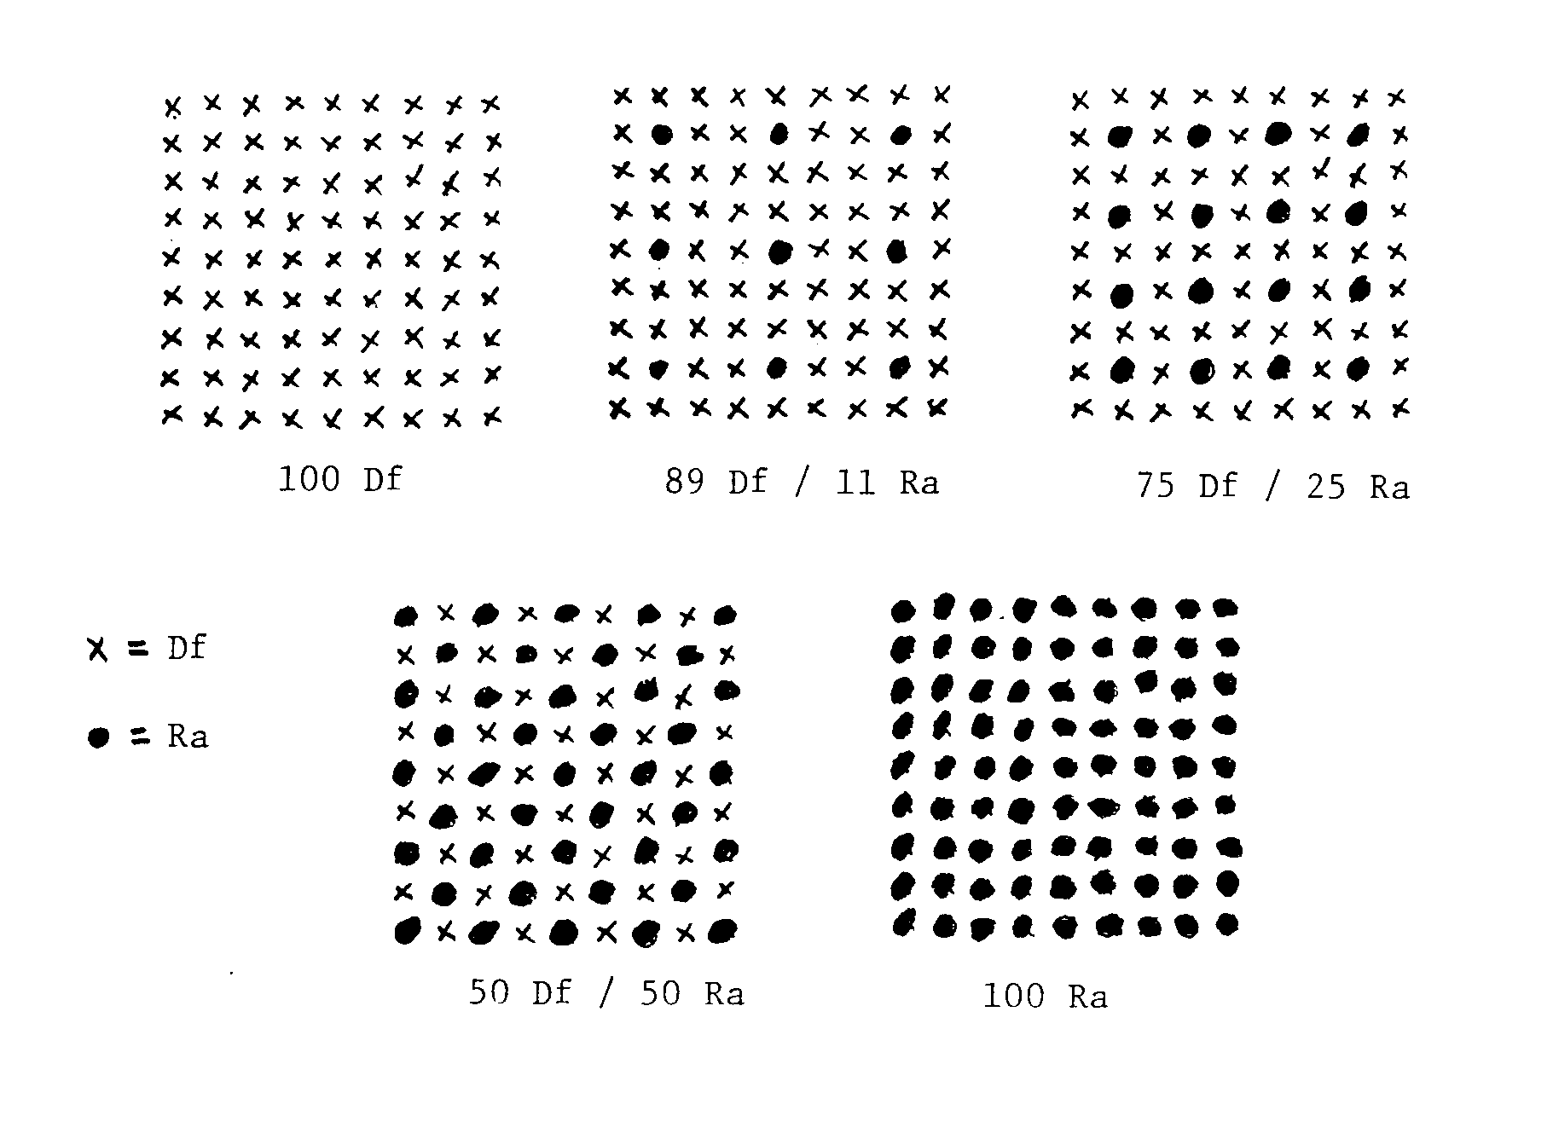

Figure 6. Type 3 species mixture patterns for different proportions of Douglas-fir and red alder. Df = Douglas-fir, Ra = red alder.

4.1.3 Site index
A range of site quality is targeted for this portion of the study. HSC staff will coordinate the selection of sites for site quality distribution. If adequate height/age data cannot be obtained for the site, data from comparable adjacent stands may be used. The comparability of adjacent sites should be assessed using plant indicators, soil characteristics, aspect, slope, slope position, and any other factors relating to site quality.
If site index is to be determined from new measurements, site trees should be 10 of the largest, well-formed, and undamaged trees per hectare. Site trees should also be well distributed in the stand, especially with respect to obvious gradients.

4.1.4 Stand uniformity and damage hazards
Our goal is to achieve uniformity and comparability in aspect, slope, plant association, stocking, site productivity, etc., among plots in an installation. The objective is to incorporate a similar range of site variation in each plot and avoid significant gradients between plots. Within a prospective site, areas of relative extremes (wet, dry, rocky, steep, understocked, etc., beyond the typical range for the site) should be excluded.
When mixed plots are established as new plantations, the site should be examined before and after the harvest of the previous stand, whenever possible. This allows assessment of both pre- and post-harvest vegetation indicators along with other post-harvest impacts on the site.
Knowledge of previous stand conditions may also allow a better evaluation of the general suitability of the site for alder establishment. Experience with planting alder in the different regions has shown wide variation in survival. Significant mortality from various combinations of frost, drought, flooding, insects, and animals has been common. While certain regions and site index classes in our sampling matrix make some hazards a likely occurrence, prevention or avoidance of known hazards is still a priority.
With the spacing control objectives of this study, evaluation of mortality agents on potential sites is very important. Potential problems should be identified and may exclude some sites from consideration. Beaver and mountain beaver have been significant mortality agents in previous research plantations. The need for prevention (trapping), protection (vexar or fencing), or avoidance must be considered if there are populations of these animals within range of a prospective site.

4.2 Plot layout, establishment, and remeasurement
4.2.1 Plantation establishment
Five 0.45 ha (1.12 ac [67.2 by 67.2 m, 220.5 ft by 220.5 ft]) blocks should be located and surveyed for planting blocks. Within each planting block there is one 0.13 ha (0.33 ac) MP. Follow the standard Type 2 protocol for MP location, surveying and marking, referencing and mapping, signs and protection, and stand establishment documentation (Sec. 3.2).
As for Type 2 installations (Sec. 3.3.1), a post-establishment evaluation after the 1st and 2nd growing seasons is required. Follow the instructions and use HSC Format 5 (Appendix E) for these evaluations. Survey and mark the MPs if the plantation is successfully established after the Year 2 evaluation.
Since there is no re-spacing of these Type 3 plantations, TP boundaries do not need to be surveyed. Some measurement may be required to ensure proper buffering during MP surveying.

4.2.2 Establishment in existing stands
When mixed plots are installed in existing stands, follow the Type 1 protocol for plot location, surveying and marking, referencing and mapping, signs and protection, and stand establishment documentation (Sec. 2.2).
Since there is only one level of spacing, crop tree designation is simplified. Mark leave trees in the entire treatment plot with blue flagging around the bole. Spacing, vigor and dominance are priority factors in selecting leave trees. The best trees at the 3.67 m (12 ft.) spacing are to be left. Instruct thinning crews to cut all unflagged trees according to rules in Sec. 2.3.4.
When mixed plots are established in existing stands, pre-establishment data (HSC Format 3, Appendix E) is required as for Type 1 alder installations (Sec. 2.3.3).

4.2.3 Remeasurement
The remeasurement period is 3 years until year 12, after which it is 5 years. Use HSC Format 7 (Appendix E) for remeasurement of both plantations and existing stand installations. All trees should be permanently tagged with the barlock method (section 2.3.3 and Appendix D) at the first measurement or, at the latest, during the second remeasurement. Maintenance should include inspection (and replacement if necessary) of reference tree markers, plot boundary markers, crop tree flagging, tree tags, and other tasks as in Sec. 2.4.3.

APPENDIX A

INSTALLATION ACCESS AND PLOT MAPS

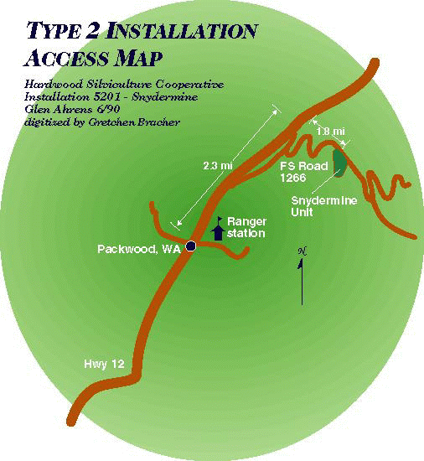

Figure A-1. Sample of Installation Access Sketch Map.

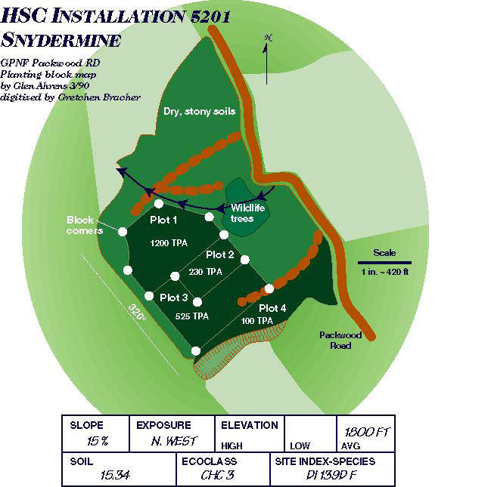

Figure A-2. Sample Planting Block Map, Type 2.

Figure A-3. Sample Measurement Plot Installation Map, Type 1.

APPENDIX B

STAND ESTABLISHMENT INFORMATION SHEET

Hardwood Silviculture Cooperative
STAND ESTABLISHMENT INFORMATION

Site name ________________________ Region___________________
Installation # (Region/Type/Site Code) __|__|__|__
Date of Establishment _ _|_ _|_ _
Legal location ____________________________
Ownership __________________________

Contact person (owner)___________________________
Address & Phone ___________________________
___________________________
___________________________

Hardwood Cooperative member responsible for installation _____________

Contact person (Coop) ___________________________
Address & Phone ___________________________
___________________________
___________________________
Adjacent ownerships__________________________________________
__________________________________________

Potential for future management activities (on or adjacent to installation) to affect research plots and protective measures taken:
_____________________________________________________________________
_____________________________________________________________________
_____________________________________________________________________

Access restrictions (locked gates, bad roads, flood or snow potential): _____________________________________________________________________
_____________________________________________________________________
_____________________________________________________________________

Aerial photograph available (Y/N)____ Source_______________
Date flown_______________ ID#____________

Type 1 installations only:
Stand age (from records and basal tree ring counts): ___________
Initial stand density (circle stems/hectare or stems/acre): ______

Type 2 installations only:
Seed source (tree seed zone number)_____________
Seedling type___________
Seedling size: average height_______ average diameter_______
Stock type (1/0 bare root, 1/0 plug, etc.)___________
Lifting date _________________
Planting date _________________

Previous treatment of site (harvest, site preparation, methods, dates):
_____________________________________________________________________
_____________________________________________________________________
_____________________________________________________________________
_____________________________________________________________________

Plant association(s) (source, vegetation type specification e.g., western hemlock/sword fern): ___________________________________________________________________
______________________________________________________________________

Site index (species, base age, number of trees measured, date, location of measurements relative to plots):
____________________________________________________________________
_____________________________________________________________________
_____________________________________________________________________
_____________________________________________________________________

Elevation__________ % slope____________ Aspect ________

Slope position (upper slope, midslope, lower slope, river terrace, flat, bench, etc.)____________________

Climatic information: Annual precipitation (cm) ______
Growing season precipitation (cm)_____
Length of growing season (days) ______

Soils information (soils classification, source, descriptions, interpretations - record here or attach separate sheet):
_____________________________________________________________________
_____________________________________________________________________
_____________________________________________________________________
_____________________________________________________________________
_____________________________________________________________________

Additional comments (wind, microsite descriptions, heavy animal use, pathogens, or anything that may significantly affect trees on research plots):
_____________________________________________________________________
_____________________________________________________________________
_____________________________________________________________________
_____________________________________________________________________
_____________________________________________________________________

APPENDIX C

LOCATING DBH, MEASURING, AND MARKING
Determination and marking of Breast Height (DBH)

Establish and mark the breast height point (DBH) measured 1.3 meters from ground level on the uphill side of the tree. For consistency in successive measurements, all measurements must be made at the same point on the tree bole. This requires a mark at breast height on all numbered trees. Mark breast height with a horizontal paint mark about 1 cm thick. Measure diameter immediately above the mark. The following DBH measurement rules are illustrated in Figure C-1.

1) If a tree forks above DBH, treat it as a single tree, with the tag and measurement below swelling caused by fork but as close as possible to normal DBH.

2) If a tree forks below DBH, treat it as two trees, with the tag and diameter measurement located at 0.6 m above the fork or 1.3 m above ground, whichever is higher.

3) If the tree has any abnormal swelling at the normal DBH point, tag and measure it immediately above the irregularity where it ceases to affect stem form.

4) On leaning trees, DBH is measured on the uphill side of the tree from the base of the tree at ground level 1.3 m along the bole.

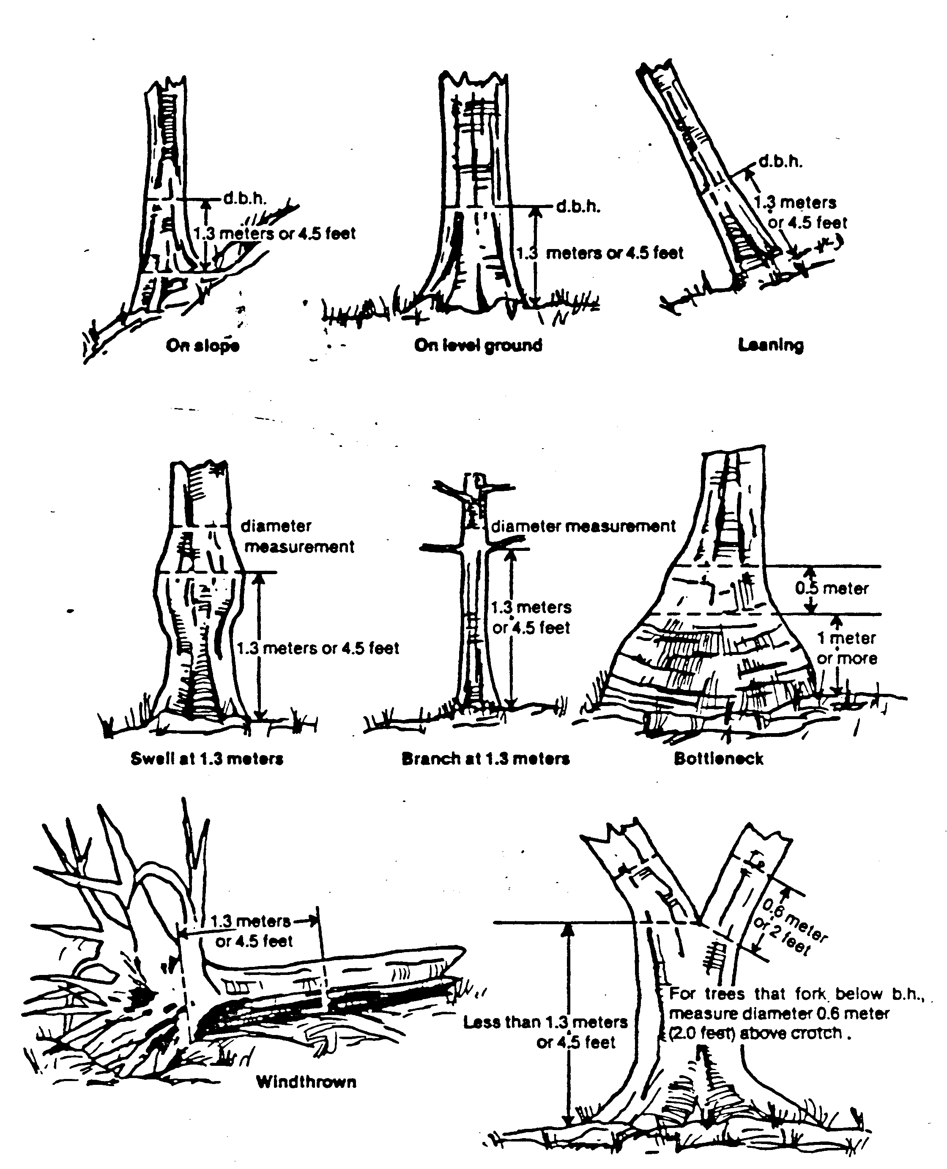
Figure C-1. Location of DBH on Various Trunk Types.

APPENDIX D

BARLOCK/TAG METHOD FOR TAGGING ALDER

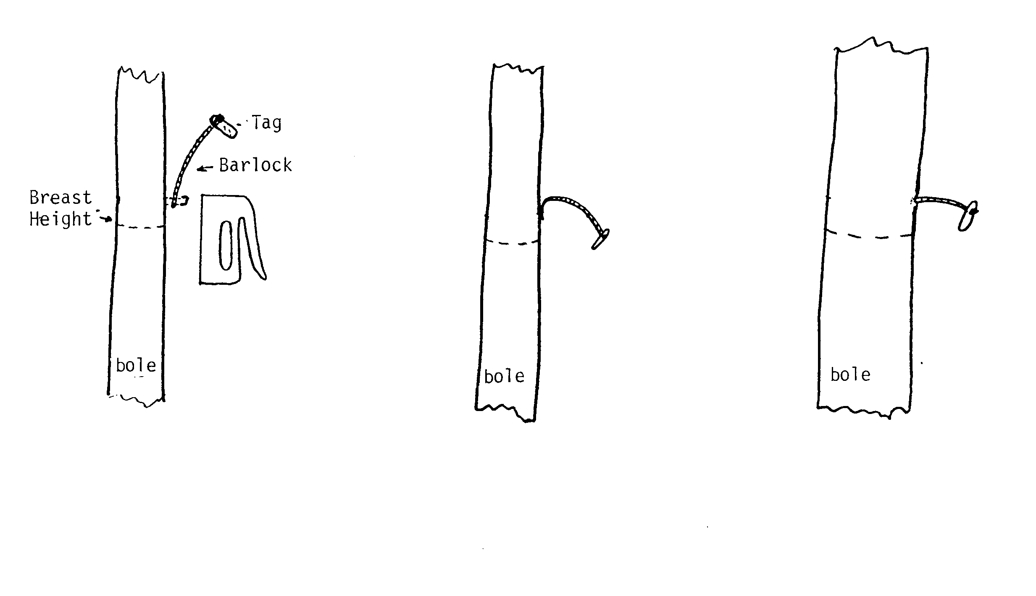
Installation Installed After diameter growth
__________________________________________________________________________
Figure D-1. Barlock /tag method for tagging alder.

APPENDIX E

CODING INSTRUCTIONS AND DATA FORMATS
***********************************************************************
FSDB Variable Format and Definitions FS106 07/20/01
***********************************************************************
Format: 3 PAGE 1 of 1

Type 1 Pre-Treatment Stem Diameters
-----------------------------------

Variable Coded Null Format Column Unit Definition
-------- ----- ---- ------ ------ ---- ----------
DC A5 1-5 DATA SET CODE

FT Y 1X,I2 7-8 DATA FORMAT TYPE

INST Y 1X,I4 9-12 INSTALLATION
NUMBER
REGION/TYPE/SITE

PLOT 1X,I2 14-15 PLOT NUMBER

EXP 1X,F4.2 17-20 HA or AC
INVERSE OF PLOT
SIZE, PERMANENT
MEASUREMENT PLOTS, PLOT SIZE
UNITS DEPEND ON
VALUE OF METRENGL

CURRDATE 1X,I6 22-27 MEASURMENT DATE
YYMMDD

M/E Y 1X,A1 29-29 METRIC OR ENGLISH
UNITS M=METRIC E=ENGLISH

TREE# Y 1X,I4 31-34 TREE TAG NUMBER

SPP Y 1X,A4 36-39 TREE SPECIES
GEnus SPecies

DBH Y 1X,I3 41-43 mm or 0.1 in
STEM DIAMETER AT
BREAST HEIGHT
(1.37m)

DEAD Y Y 1X,A2 45-46 DEAD TREE CODE
”D"=DEAD

COMMENTS Y 1X,A30 47-76 MISC. COMMENTS

HSC Coding Instructions

Format 3: Type 1 Pre-Treatment Stem Densities

DC=Data Code: FS106 (designated for this study)

FT=Data Form Type: 3

Inst=Installation Number: XXXX

first digit: code for region (see Table 1)
second digit: installation type (2)
last two digits: code for site (assigned at establishment)

Plot=Plot Number: XX

Designated plot number within an installation

Exp=Expansion factor XXXX
Inverse of measurement plot size in either Ha or Ac

CurrDate=Current Date: XXXXXX

Year/month/day of current measurements

M/E=System of measurement

M=metric, E=English

Tree#=Tree tag number: XXXX

Spp=Species: XXXX

Tree species identified by four-letter code as follows

ALRU red alder PSME Douglas-fir PISI Sitka spruce
THPL western redcedar TSHE western hemlock ACMA bigleaf maple

PREM bitter cherry BEPA paper birch POTR black cottonwood

DBH=Diameter breast height: XXX

Measure by diameter tape to the nearest mm (or 0.1 in.) directly above DBH paint mark or at DBH (1.37m) if no mark exists.

Examples: record 16.2 cm DBH as 162; record 9.6 in DBH as 96

DEAD= Dead tree X
If the tree is dead, record a D in this column. Otherwise leave blank.

Comments:

Use this column to indicate or describe any other environmental or biological condition, which may affect the growth performance/survival of a tree. For example, use the comments section to give a more specific cause of damage or condition (such as "rub" or "browse" if there is animal damage, or "bt" following environmental damage). See Table 3 for a list of definitions for the abbreviated comments used.
**************************************************************************
FSDB Variable Format and Definitions FS106 07/20/01
**************************************************************************
Format: 5 PAGE 1 of 1

Plantation Monitoring Data- Seedling Height
-------------------------------------------

Variable Coded Null Format Column Unit Definition
-------- ----- ---- ------ ------ ---- ----------
DC A5 1-5 DATA SET CODE

FT Y 1X,I2 7-8 DATA FORMAT TYPE

INST Y 1X,I4 10-13 INSTALLATION NUMBER
REGION/TYPE/SITE
CURRDATE 1X,I6 15-20 DATE OF MEASURMENTS
YYMMDD

M/E Y 1X,A1 22-22 METRIC OR ENGLISH UNIT
DESIGNATION M=METRIC E=ENGLISH

BLOCK 1X,I3 24-26 PLANTING BLOCK NUMBER

EXP 1X,F5.1 28-32 HA/AC INVERSE OF
CIRCULAR PLOT SIZE
EXPFACT*TREE COUNT=TREES/HA OR AC UNITS DEPEND ON VALUE
OF METRENGL

PLOT 1X,I3 34-36 PLANTATION MONITORING
PLOT NUMBER PLOTS ARE
SYSTEMATICALLY LOCATED
.02 ACRE CIRULAR PLOTS

SPP Y 1X,A4 38-41 TREE SPECIES
GEnus SPecies

HEIGHT Y 1X,I3 43-45 cm TOTAL HEIGHT OF
PLANTED SEEDLING

NODE Y 1X,I3 47-49 cm NODE HEIGHT, PREVIOUS
YEAR'S HEIGHT

COND Y Y 1X,I2 51-52 CONDITION CODES
SEE MANUAL FOR CODES

COMMENTS Y 1X,A30 54-84 COMMENTS PERTAINING TO
PLOT OR TREE

HSC Coding Instructions

Format 5: Plantation Monitoring Data-Seedling Height

DC=Data Code: FS106 (designated for this study)

FT=Data Form Type: 7

Inst=Installation Number: XXXX

first digit: code for region (see Table 1)
second digit: installation type (2)
last two digits: code for site (assigned at establishment)

CurrDate=Current Date: XXXXXX

Year/month/day of current measurements

M/E=System of measurement

M=metric
E=English

Block=Block Number: XX

Planting block number as designated on installation maps and block corner markers

Exp=Expansion factor XXXX
Inverse of measurement plot size in either Ha or Ac

Plot=Plot number: XX

Sample plot number in sequential order across entire installation

Spp=Species: XXXX

Tree species identified by four-letter code as follows

ALRU red alder PSME Douglas-fir PISI Sitka spruce
THPL western redcedar TSHE western hemlock ACMA bigleaf maple

PREM bitter cherry BEPA paper birch POTR black cottonwood

HT=Total height: XXX

Mean total height of species. Measure to nearest cm (or 0.1 foot).

HSC Coding Instructions Format 6: Plantation Monitoring Data-Seedling Height (con’t)

Node= Height to last node: XXXX

Height in cm (or 0.1ft) on uphill side of seedling to the last node (previous years total height).

Cond=Condition: XX

A two digit code designates dead and damaged trees, with room for two general causal agents:

First digit: 1 = damaged
2 = dead

Second and third digits: 2 = weather/other environmental
3 = animal damage
4 = human damage
5 = insect damage
6 = disease
7 = unknown
9 = suppression

Comments:

Use this column to indicate or describe any other environmental or biological condition which may affect the growth performance/survival of a tree. For example, use the comments section to give a more specific cause of damage or condition (such as "rub" or "browse" if there is animal damage, or "bt" following environmental damage). See Table 3 for a list of definitions for the abbreviated comments used in Format 7.
**************************************************************************
FSDB Variable Format and Definitions FS106 07/20/01
**************************************************************************
Format: 6 PAGE 1 of 1

Plantation Monitoring Data- Vegetation Cover
--------------------------------------------

Variable Coded Null Format Column Unit Definition
-------- ----- ------ ------ ---- ----------
DC A5 1-5 DATA SET CODE

FT Y 1X,I2 7-8 DATA FORMAT TYPE

INST Y 1X,I4 10-13 INSTALLATION NUMBER
REGION/TYPE/SITE

CURRDATE 1X,I6 15-20 DATE OF MEASURMENTS
YYMMDD

M/E Y 1X,A1 22-22 METRIC OR ENGLISH UNIT
DESIGNATION M=METRIC E=ENGLISH

BLOCK 1X,I3 24-26 PLANTING BLOCK NUMBER

EXP 1X,F5.1 28-32 HA/AC INVERSE OF
CIRCULAR PLOT SIZE
EXPFACT*TREE COUNT=TREES/HA OR AC UNITS DEPEND ON VALUE
OF METRENGL

PLOT 1X,I3 34-36 PLANTATION MONITORING
PLOT NUMBER PLOTS ARE
SYSTEMATICALLY LOCATED
.02 ACRE CIRULAR PLOTS

SPP Y 1X,A4 38-41 FOUR LETTER SPECIES
CODE
GEnus SPecies

HEIGHT Y 1X,I3 43-45 cm MEAN SPP HEIGHT

COVER Y 1X,I3 47-49 Percent
SUM OF SHRUB AND HERB SPP COVER
CAN EXCEED 100%

COMMENTS Y 1X,A30 54-83 COMMENTS PERTAINING TO
PLOT OR TREE

HSC Coding Instructions

Format 6: Plantation Monitoring Data-Vegetation Cover

DC=Data Code: FS106 (designated for this study)

FT=Data Form Type: 7

Inst=Installation Number: XXXX

first digit: code for region (see Table 1)
second digit: installation type (2)
last two digits: code for site (assigned at establishment)

CurrDate=Current Date: XXXXXX

Year/month/day of current measurements

M/E=System of measurement

M=metric
E=English

Block=Block Number: XX

Planting block number as designated on installation maps and block corner markers

Exp=Expansion factor XXXX
Inverse of measurement plot size in either Ha or Ac

Plot=Plot number: XX

Sample plot number in sequential order across entire installation

Spp=Species: XXXX

Tree species identified by four-letter code as follows

ALRU red alder PSME Douglas-fir PISI Sitka spruce
THPL western redcedar TSHE western hemlock ACMA bigleaf maple

PREM bitter cherry BEPA paper birch POTR black cottonwood

HT=Total height: XXX

Mean total height of species. Measure to nearest cm (or 0.1 foot).

HSC Coding Instructions Format 6: Plantation Monitoring Data-Vegetation Cover (con’t)

Cover= Vegetative Cover: XXX

Sum of shrub and herb species cover, can exceed 100%

Comments:

Use this column to indicate or describe any other environmental or biological condition which may affect the growth performance/survival of a tree. For example, use the comments section to give a more specific cause of damage or condition (such as "rub" or "browse" if there is animal damage, or "bt" following environmental damage). See Table 3 for a list of definitions for the abbreviated comments used in Format 7.
************************************************************************
FSDB Variable Format and Definitions FS106 07/20/01
************************************************************************
Format: 7 PAGE 1 of 2

Plantation Remeasurement Data
-----------------------------

Variable Coded Null Format Column Unit Definition
-------- ----- ---- ------ ------ ---- ----------
DC A5 1-5 DATA SET CODE

FT Y 1X,I2 7-8 DATA FORM CARD TYPE

INST Y 1X,I4 10-13 INSTALLATION NUMBER
REGION/TYPE/SITE

CurrDate 1X,I6 23-28 DATE OF MEASURMENTS
YYMMDD

PLOT 1X,I2 15-16 PLOT NUMBER

EXP Y 1X,F4.2 18-21 HA/AC INVERSE OF PLOT SIZE
PERMANENT SQUARE
MEASUREMENT PLOTS.
PLOT SIZE UNITS DEPEND
ON VALUE OF METRENGL

M/E Y 1X,A1 30-30 METRIC OR ENGLISH UNIT
DESIGNATION M=METRIC
E=ENGLISH

TMT Y 1X,I3 32-34 TREATMENT NUMBER FROM
MANUAL, TABLE 2 OR 5.

EstDate 1X,I6 36-41 DATE OF INSTALLATION
ESTABLISHMENT YYMMDD

LastDate 1X,I6 43-48 LAST DATE OF
MEASUREMENT YYMMDD

Tree# 1X,I4 50-53 TREE TAG NUMBER

Spp Y 1X,A4 55-58 FOUR LETTER SPECIES
CODE, GEnus SPecies

SPCNG Y 1X,I3 60-62 CROP TREE SPACING CODES
SEE MANUAL FOR USAGE

DBH Y 1X,I4 64-67 mm or 0.1in
STEM DIAMETER AT
BREAST HEIGHT (1.37m)

HT Y 1X,I4 69-72 mm or 0.1ft
TOTAL TREE HEIGHT

- Format continued on next page <

************************************************************************
FSDB Variable Format and Definitions FS106 07/20/01
************************************************************************
Format: 7 PAGE 2 of 2

Plantation Remeasurement Data
-----------------------------

Variable Coded Null Format Column Unit Definition
-------- ----- ---- ------ ------ ---- ----------
HLC Y 1X,I4 74-77 mm or 0.1ft
HEIGHT TO BASE OF LIVE
CROWN. SEE MANUAL FOR DEFINITION

FORK Y Y 1X,I2 79-80 FORKED TREE CODES
SEE MANUAL FOR CODES

ForkHT Y 1X,I4 82-85 mm or 0.1ft
HEIGHT TO FORK SEE MANUAL FOR DEFINITION

LEAN Y 1X,I2 87-88 Degrees
ANGLE OF LEAN
FOR LEAN >10 DEGREES

DEV Y 1X,I2 90-91 Inches
AMOUNT OF SWEEP IN 8FT BUTT LOG

COND Y Y 1X,I2 93-94 CONDITION CODES
SEE MANUAL FOR CODES

COMMENTS Y 1X,A30 96-125 COMMENTS PERTAINING TO
PLOT OR TREE

HSC Coding Instructions

Format 7: Plantation Remeasurement Data

DC=Data Code: FS106 (designated for this study)

FT=Data Form Type: 7

Inst=Installation Number: XXXX

first digit: code for region (see Table 1)
second digit: installation type (2)
last two digits: code for site (assigned at establishment)

Exp=Expansion factor XXXX
Inverse of measurement plot size in either Ha or Ac

CurrDate=Current Date: XXXXXX

Year/month/day of current measurements

Plot=Plot Number: XX

Designated plot number within an installation

M/E=System of measurement

M=metric
E=English

TMT=Treatment Number: XXX

Designated treatment # for a plot within an installation (see Table 2)

EstDate=Establishment Date: XXXXXX

Year/month/day of plantation establishment

LastDate=Last Measurement Date: XXXXXX

Year/month/day of last previous measurement

Tree#=Tree tag number: XXXX

HSC Coding Instructions for Format 7: Plantation Remeasurement Data (con’t)

Spp=Species: XXXX

Tree species identified by four-letter code as follows

ALRU red alder PSME Douglas-fir PISI Sitka spruce
THPL western redcedar TSHE western hemlock ACMA bigleaf maple

PREM bitter cherry BEPA paper birch POTR black cottonwood

Spcng=Spacing code: XXX

1st digit: 1296 tph (525 tpa) 0 (no) or 1 (yes)
2nd digit: 568 tph (230 tpa) 0 or 1
3rd digit: 247 tph (100 tpa) 0 or 1

For example:
Crop tree at 230 tpa=010, Crop tree at 100 tpa=001, Not a crop tree=000

This is only consistently used when designating ‘leave’ trees during thinning treatments (Dxxxxf7, Fxxxxf7, and Hxxxxf7)

DBH=Diameter breast height: XXX

Measure by diameter tape to the nearest mm (or 0.1 in.) directly above DBH paint mark or at DBH (1.37m) if no mark exists.

Examples: record 16.2 cm DBH as 162; record 9.6 in DBH as 96

HT=Total height: XXXX

Measure to nearest cm (or 0.1 foot) for a subsample of all trees on the MP. The subsample should be at least 40 well-distributed trees covering the range of DBH’s. Must measure the 10 largest, the 10 smallest, and 20 in-between trees.

For leaning trees measure the height from a direction perpendicular to the direction of lean. If the lean is more than 10 degrees calculate true length of bole.

Examples: record 16.2 meter tall tree as 1620 (cm); record 56.3 feet height as 563

HLC=Height to base of the live crown: XXXX

Measure HLC to the nearest cm (or 0.1 foot) for the subsample of tagged trees selected for total height measurement. HLC is the distance from the base of the tree to the base of the live crown. The base of the live crown is the lowest point (whorl) on the bole with live branches originating in at least three of the four quadrants, exclusive of epicormic branching.

HSC Coding Instructions for Format 7: Plantation Remeasurement Data (con’t)

Fork=Forked tree: XX

Record a code for all trees in the measurement plot.

00 for unforked trees
01 for trees forked above DBH
X1 for forks below DBH: 1st digit (X) is total number of stems within clump

ForkHt=Height to the fork: XXXX

Record the height to the fork to the nearest cm (or 0.1 foot) for all forked trees in the measurement plot at year 12 and beyond (Ixxxxf7, Jxxxxf7, etc.)

Lean=Angle of lean: XX

Record the angle of lean (in degrees) for trees leaning more than 10 degrees. This can usually be done by holding the long edge of a clinometer or compass parallel to the lean, and reading the angle in degrees from the scale.

Dev=Stem curvature: XX

Record the existence and severity of stem sweep for all trees. For the 8 foot butt log (1 to 9 feet off of the ground), record the maximum distance, in inches, between the bole and a straight pole touching the tree at the 1 and 9 foot heights, regardless of lean.

Cond=Condition: XX

A two digit code designates dead and damaged trees, with room for two general causal agents:
First digit: 1 = damaged
2 = dead
Second and third digits: 2 = weather/other environmental
3 = animal damage
4 = human damage
5 = insect damage
6 = disease
7 = unknown
9 = suppression

Comments:

Use this column to indicate or describe any other environmental or biological condition which may affect the growth performance/survival of a tree. For example, use the comments section to give a more specific cause of damage or condition (such as "rub" or "browse" if there is animal damage, or "bt" following environmental damage). See “Comment Codes” (Appendix E) for a list of definitions for the abbreviated comments used in Format 7.
**************************************************************************
FSDB Variable Format and Definitions FS106 03/31/01
**********************************************************************
Format: 8 PAGE 1 of 1

Type 2 Seedling Sample: Measurements at Time of Planting
--------------------------------------------------------

Variable Coded Null Format Column Unit Definition
-------- ----- ---- ------ ------ ---- ----------
DC A5 1-5 DATA SET CODE

FT Y 1X,I2 7-8 DATA FORMAT TYPE

INST Y 1X,I4 10-13 INSTALLATION NUMBER
REGION/TYPE/SITE
CURRDATE 1X,I6 15-20 DATE OF MEASURMENTS
YYMMDD

M/E Y 1X,A1 22-22 METRIC OR ENGLISH UNIT
DESIGNATION M=METRIC E=ENGLISH

SPP 1X,I4 24-27 FOUR LETTER SPECIES
CODE
GEnus, SPecies

HEIGHT Y 1X,I3 29-31 cm TOTAL HEIGHT OF
PLANTED SEEDLING

BASD 1X,I3 33-35 0.1mm BASAL DIAMETER
MEASURED 1 CM ABOVE ROOT COLLAR

COMMENTS Y 1X,A30 49-88 COMMENTS PERTAINING TO
PLOT OR TREE

Comment codes and definitions for HSC Data
Abbreviation | Definition
abrasion | rub from adjacent tree
basal | basal cambium damage on seedling
bear | bear damage
bent | bent tree
bird | bird (most commonly sapsucker) damage
blister | blister
blk | black and rough around knots and branch stubs
borer | borer (insect) damage
browse | deer or elk browse
bt | broken top
cank | canker on trunk
cat | catface
chlo | chlorotic foliage
crack | frost crack
crook | kink/crook in stem, most likely the result of an old broken top
crush | seedling/tree was crushed by treefall/boulder
cut | leave tree accidently cut down during thinning
dblfork | more than one fork
debris | planted in or damaged by logging slash/wood
dp | double planted
dt | dead top: if followed by a number, that is the height to dead top in cm
duff | seedling planted in duff
epi | epicormic branch
fork | forked tree
frost | frost damage to leaves
gird | girdled
gld | groundline or basal diameter
gopher | gopher damage
herbicide | herbicide damage
ingr | ingrowth, not a planted tree
jroot | bad planting job, jrooted
mbeav | mountain beaver (boomer) damage
mice | mice damage
miss | missing tree
nat | non-planted or natural tree
NE | NE corner
near??? | tag number of nearest tree
notag | no tag present
ntag | new tag number put on tree
NW | NW corner
oldbt | previous broken top, not affecting growth so much as form
olddt | previous dead top, not affecting growth so much as form
oos | tree is out of sequence
ram | ramicorm branch present
rd | damaged during release (same as herbicide?)
redb | red blister on trunk
replant | replanted/interplanted seedling
rub | deer or elk antler rub
scar | scar/cat face (either natural or human caused)
SE | SE corner
sept | septoria
shot | bullet damage
snc | Swiss Needle Cast
snow | snow or ice damage/breakage
soot | sooty appearance of trunk
sprt | tree of sprout origin
squirrel | squirrel damage
staple | trunk deformity/damage caused by the tag staple
stump | stump
sun | sunscald damage
SW | SW corner
tag | damage from tree growing over/around tag
trail | yarding/animal/human trail
trample | trampled tree/on a trail
tube | damage from planting tube
uproot | uprooted/blown over
wasp | wasp damage
wet | wet/soggy spot
wobble | wobble/sinuosity in trunk

APPENDIX F

RED ALDER SITE QUALITY EVALUATION GUIDE
Harrington, Constance A. A method of site quality evaluation for red alder. Gen. Tech. Rep. PNW-192. Portland, OR: U.S. Department of Agriculture, Forest Service, Pacific Northwest Research Station; 1986. 22 pps.

A field guide to predict site index for red alder (Alnus rubra Bong.) was developed for use in western Washington and Oregon. The guide requires the user to evaluate 14 soil-site properties that are grouped into three general factors: (1) geographic and topographic position, (2) soil moisture and aeration during the growing season, and (3) soil fertility and physical condition. Construction of the guide was modeled after a method of site evaluation developed for several southern hardwood species. The red alder model is accurate when used properly. The correlation (r) between predicted and measured site index was 0.97 for the basic data set of 25 plots and 0.96 for the 15 plots used for verification. Estimated site index should be within +/- 2 meters of measured site index 95 percent of the time. Use of a second independent data set for model verification resulted in a somewhat lower correlation (r = 0.89) between measured and predicted site index than was achieved with the original data set, but the model continued to meet the accuracy standard of +/- 2 meters (p-<0.05).

Keywords: Site class, site index, guidebooks, models, red alder, Alnus rubra.
Table 2-Red alder site evaluation guide: factor 1, geographic and topographic position
________________________________________________________________________________
Soil-site property Level of property Site points for each level
______________________________________________________________________________
Elevation Less than 100 m 8
200 - 300 m 7
400 - 500 m 6
600 - 700 m 5
800 - 900 m 4
1000 - 1100 m 3
Greater than 1200 m Unsuitable

Physiographic Flood plain 5
position Terrace or bench (includes lower slope
positions with slope <20 percent) 4
Lower slope positions with
slope >20 percent and midslope positions 3
Depression in landscape, bog, or marsh 2
Upper slope positions 1
Ridgetop 0

Aspect and Any aspect when slope 5 percent or less 4
slope E or W with slope 10-20 percent; or
N, NE, or NW with slope 10-30 percent 3
S, SE, or SW with slope 10-20 percent; or
E or W with slope 25-35 percent; or
N, NE, or NW with slope 35-45 percent 2
S, SE, or SW with slope 25-35 percent; or
E or W with slope 40-50 percent; or
N, NE, or NW with slope 50-60 percent 1
(Subtract 1/2 for each additional
1 0-percent increase in slope)

Precipitation Greater than 45 cm 3
from April 1 30 - 40 cm 2
through Sept. 30 20 - 25 cm 1
Less than 15 cm 0

Special hazards None 0
Frost pocket -2
Exposed windy site -3
________________________________________________________________________________
Maximum score for factor 1 = 20.
Table 3-Red alder site evaluation guide: factor 2, soil moisture and aeration during the growing season.
_____________________________________________________________________________
Site points
Soil-site property Level of property for each level
_____________________________________________________________________________
Internal drainage Soil generally well drained and composed
of many thin alluvial layers (stratified) 4

Soil generally well drained and profile
contains buried horizons or soil lenses
within a horizon that differ in texture from
the surrounding horizon, or A and B horizons
that differ in sand content by more than
10 percent; or soil moderately well drained 3

Well drained (without special features);
or generally somewhat excessively drained
with multiple thin alluvial layers, buried
horizons, soil lenses within a horizon that
differ in texture from the surrounding
horizon or A and B horizons that differ
in sand content by more than 10 percent 2

Somewhat excessively drained (without
special features); or somewhat poorly drained 1

Poorly drained mineral soil; or very
poorly drained mineral soil with organic
surface layers; or excessively drained
mineral soil 0

Very poorly drained Unsuitable
Table 3- Red alder site evaluation guide: factor 2, soil moisture and aeration during the growing season. (Continued)
______________________________________________________________________________
Site points
Soil-site property Level of property for each level
______________________________________________________________________________
Texture Silt loam, silty clay loam, or
loam with at least 40 percent silt 3

Clay, clay loam, silty clay, or
loam with less than 40 percent silt 2

Sandy clay, sandy clay loam, or
sandy loam 1

Sand or loamy sand 0

Soil depth Greater than 80 cm without cemented
or compacted layers 2

Between 40 and 75 cm without
cemented or compacted layers 1

Less than 35 cm or deeper soils
with cemented or compacted layers
within 35 cm of the surface 0

Rock and gravel 0 - 25 percent (by weight) 1
content (less than 30 - 50 percent 0
50 cm) More than 55 percent -2

Depth to 1.8 - 3 m 2
water table 1 - 1.5 m or greater than 4 m 1
(in summer) Less than 0.75 m 0
__________________________________________________________________________
Maximum score for factor 2 = 12
Table 4- Red alder site evaluation guide: factor 3, soil fertility and physical condition.
_____________________________________________________________________________
Soil-site property Level of property Site points for each level
_____________________________________________________________________________
Parent material Young soils composed of water-
carried silt deposits; presence of
soil layers caused by water
deposition not weathering 4

Some profile development evident
but no leached horizons; parent
material sedimentary or volcanic
rocks (especially soils with low
coarse fragment content developed
from siltstone, sandstone, shale,
or basalt); includes loessial soils
if deposits are thick 3

Some profile development evident but
no leached horizons; parent material
coarse alluvial, glacial or volcanic
deposits (or soils with high coarse
fragment content developed from
sedimentary or volcanic rocks) 2

Highly weathered mineral soils
with evidence of leaching-, or
organic soils 1

pH 4.6 - 5.5 2
(in surface 3.8 - 4.3 or 5.8 - 7.5 1
horizon) 3.2 - 3.5 0
Less than 3.0 or greater than 8.5 Probably unsuitable

Organic matter 5 to 20 percent 2
(in surface 10 cm) Less than 3 or greater than 25 percent 1

Bulk density Less than l.2 g/cm³ 0
1.4 g/cm³ or greater -2
________________________________________________________________________________
Maximum score for factor 3 = 8.
Appendix 1: Definition of Terms Used in Tables

Factor 1
Elevation: Mean elevation above sea level in meters. Should be determined to nearest 25 m.

Precipitation, April 1 through September 30: Can be determined from weather records or maps of rainfall distribution. Users should try to compensate for differences in precipitation between the site being evaluated and the nearest weather station or map averages. In particular, the effect of elevation on precipitation should be taken into account.

Physiographic position:
Flood plain-On a level plain associated with a river system, the width of a flood plain is determined by the size of the river and the associated topography. A site should probably not be considered to be on a flood plain unless it is subject to flooding during high water at least once every 10 to 15 years.

Terrace or bench-Site generally level or somewhat rolling with slope less than 15 percent, and far enough from a river or high enough to be rarely or never flooded. Also includes lower slope positions on side slopes when slope is less than 20 percent. In contrast to midslope positions, sites in this category are considered to be in a generally moisture-gaining position.

Midslope-Includes midslope Positions and lower slope positions with slope greater than 20 percent. Such sites are considered to have minimal net change in soil moisture-. that is, gains in soil moisture caused by additions from upslope positions would be approximately balanced by losses to sites farther down the slope. Would probably be the most common physiographic position encountered.

Marsh or bog-Depression in landscape with limited downward movement of water,
often in a position to gain soil moisture from surrounding area.

Upper slope-Side slope positions just below the top of the hill. Considered to have a
net loss in soil water but to be less exposed than ridgetop positions.

Ridgetop-Along top of ridge or hill. Considered to have a net loss in soil moisture and to be the position most exposed to wind. True ridgetop positions are the most unfavorable physiographic positions in terms of tree growth. The user should assign a higher value for physiographic position if the site being evaluated is on top of a hill or ridge but is located on a fairly level plateau, is in a minor depression, or is sheltered by surrounding features. The value assigned should be based on the user's evaluation of water movement and wind exposure.

Special hazards: Recognition of special hazards and assignment of negative site points can best be done by users with knowledge of local conditions. Sites with special hazards would include those located in frost pockets (either natural or created by cutting). Windy, exposed sites-such as those close to the Pacific Ocean without blocking topographic features, or areas in the vicinity of mountain passes-are examples of other conditions that need to be taken into account.

Factor 2
Internal drainage: Well-drained and excessively drained soils should be carefully evaluated for the presence of special soil features; such evaluation can be done from a detailed profile description or from examination of a soil pit.

Texture: As determined from a textural triangle after mechanical analysis. With practice, texture can be estimated fairly well in the field, especially with the use of published definitions of soil textural classes based on feel and field experience (Soil Survey Staff 1975).

Soil depth: Mean soil depth that roots and water can easily penetrate, can be determined by use of an auger or by examination of a soil pit. The user should try to determine effective rooting depth rather than depth to bedrock.

Rock and gravel content. Can be determined by sieving soil samples or by visual and textural examination. If the soil is not compacted and the rocks do not contain a lot of trapped air (for example, pumice or similar material), multiplying the percentage of rock and gravel volume by 2 will approximate the percentage of rock and gravel weight

Depth to water table: The average depth to water table during the growing season; can be determined by soil boring or by comparison of site elevation in relation to the water level in nearby streams or lakes. Use of intermittent or very shallow streams to evaluate water table level is not recommended.

Factor 3
Parent material and age: Published soil survey information can be helpful in determining
parent material; however, many categories can be easily recognized in the field.

pH: Measure of soil acidity can be determined in the field or on fresh samples in the off ice with a pH meter or a pH testing kit. Can be estimated from soil survey information if description of mapped soil agrees well with what is observed at the site.

Organic matter. The organic portion of a mineral soil composed of plant and animal remains in various stages of decomposition. Most accurately determined in the laboratory, but with practice can be estimated in the field. Surface soils low in organic matter do not differ much in color from lower layers and generally are light colored. Soils high in organic matter are usually very dark in color and both well-decomposed material (greasy feeling) and partially decomposed materials (origin somewhat evident) can be distinguished.

Bulk density: Measure of soil compaction expressed as ovendry soil weight per unit of volume. Most accurately measured with equipment designed for such determination, but with practice can be estimated in the field. Soils with low bulk density are loose, porous, or friable. Soils with high bulk density are tight and strongly compacted.

Appendix 2: Sample Field Worksheet
Site evaluations for red alder
_____________________________________________________________________________
Site name or number:___________________________________________________________
Location:_____________________________________________________________________
Soil-site factors
_____________________________________________________________________________
1 2 3
Geographic and Soil moisture and aeration Soil fertility and physical
topographic position during the growing season condition
Soil-site Score for Soil-site Score for Soil-site Score for
property this site property this site property this site
Elevation _______ Internal Parent material
drainage ______ and age ______
Physiographic
position _______ Texture ______ pH ______

Aspect and slope _______ Soil depth ______ Organic matter ______

Precipitation _______ Rock and gravel Bulk density ______
content ______
Special hazards _______
Depth to water
table ______

Total for factor 1 _______ Total for factor 2 ______ Total for factor 3 ______
____________________________________________________________________________

Total for all factors =_____________.

S1₅₀ =____________m .
REFERENCES

Ahrens, G.R., A. Dobkowski, and D.E. Hibbs. 1992. Red alder: guidelines for successful regeneration. Special Publication 24. Forestry Research Lab., School of Forestry, Oregon State University. 15 pps.

Franklin, J.F. and C.T. Dyrness. 1969. Vegetation of Oregon and Washington. Research Paper PNW-80. Portland, OR: U.S. Department of Agriculture, Forest Service, Pacific Northwest Research Station. 216 pps.

Harrington, C.A. 1986. A method of site quality evaluation for red alder. Gen. Tech. Rep. PNW-192. Portland, OR: U.S. Department of Agriculture, Forest Service, Pacific Northwest Research Station. 22 pps.

Harrington, C.A., and R.O. Curtis. 1986. Height growth and site index curves for red alder. U.S. Department of Agriculture, Forest Service, Research Paper PNW-358.

Hibbs, D.E. and A.A. Ager.1989. Red alder: Guidelines for Seed Collection, Handling, and Storage. Special Publication 18. Forestry Research Lab., School of Forestry, Oregon State University. 6 pps.

Johnson, F.A. and N.P. Worthington 1963. Procedure for developong a site index estimating system from stem analysis. U.S. Department of Agriculture, Forest Service, Research Note PNW-170.

Worthington, N.P., F.A. Johnson, G.R. Staebler, and W.J. Lloyd. 1960. Normal Yield tables for red Alder. U.S. Department of Agriculture, Forest Service, Research Paper PNW-36.

